Nama : Dzaky Faishalariq

NPM : G1A020003

Kelas : Informatika A

Tugas PBO java oop

Soal

**Practice 1 :**

Pada tugas practice satu ini kita ditugaskan untuk mendwonload dan menginstal java berupa jdk dan teks editor bebas, dengan menguji coba pogram java pertama kali menampilkan print “hello world”.

Jawab :

1. Menginstal java di computer

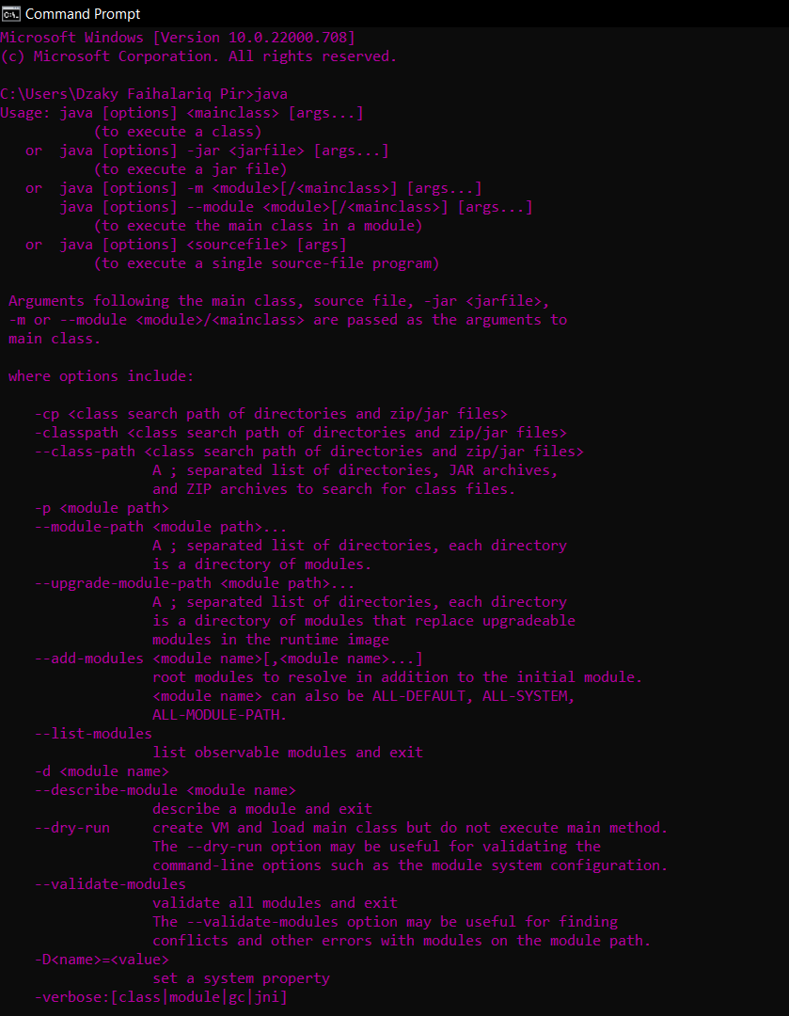

1. Versi java yang di install

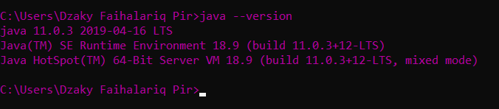

1. Menguji coba di pogram java

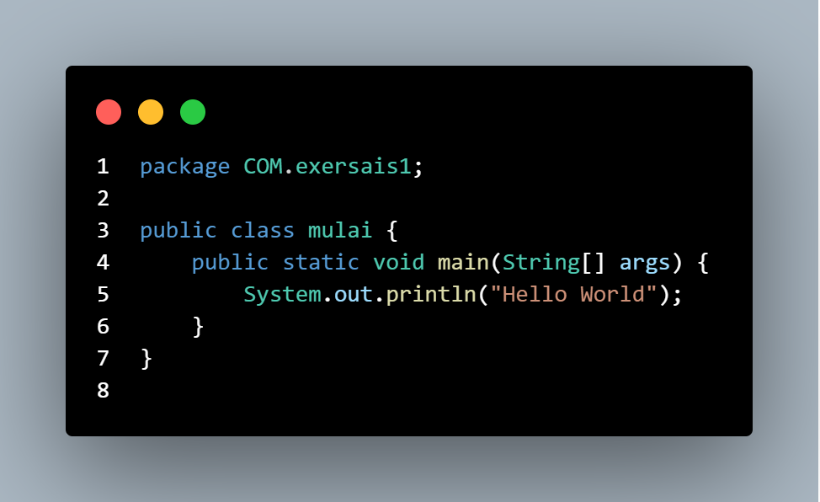

Outputnya :

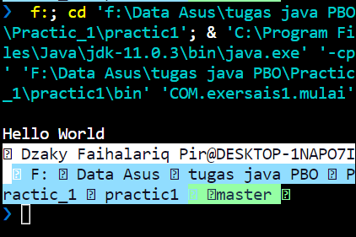

**Practice 2:**

1. Problem 1: Simple ASCII Art



Overview

Using text to create a picture is known as ASCII art. In section 2, we made an ASCII art cat. In this practice,

you’ll use print statements to recreate the image above.

Task

Use 8 print statements to recreate the smiley face above. Your art will rely on only a single character, besides

space, such as X or #.

The ProblemSet2_1 project is available to help you get started.

Jawab :

1. Struktur projek

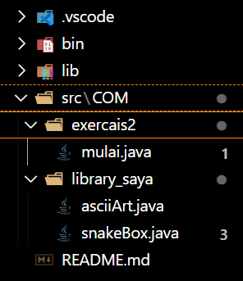

1. Code method asciiArt problem 1:

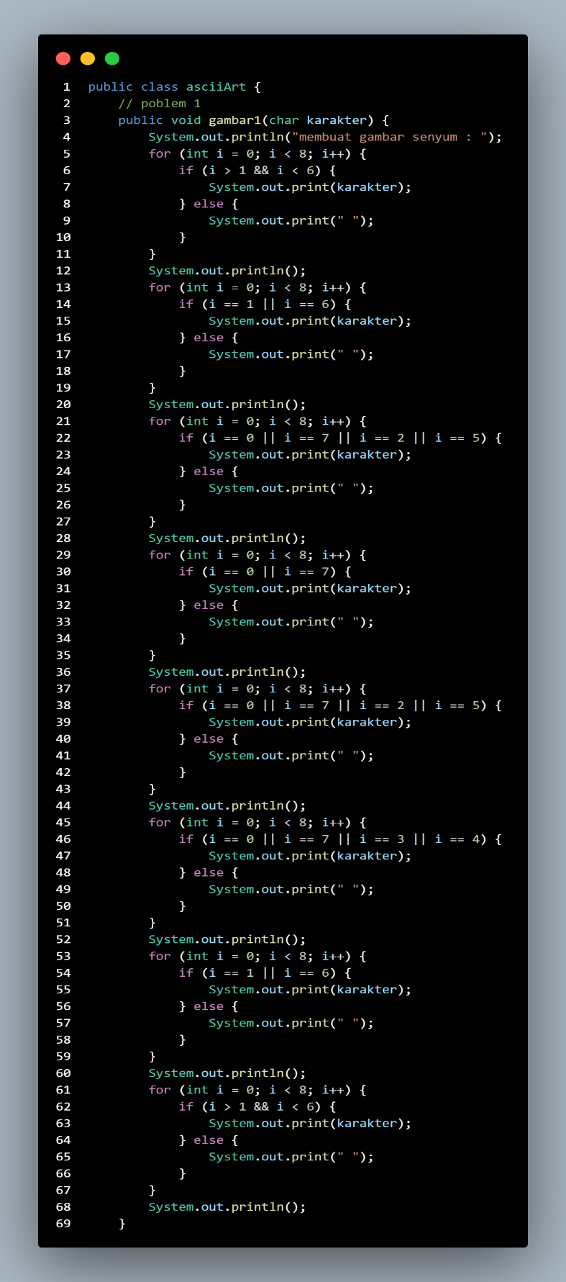

1. Code method asciiArt problem 2:

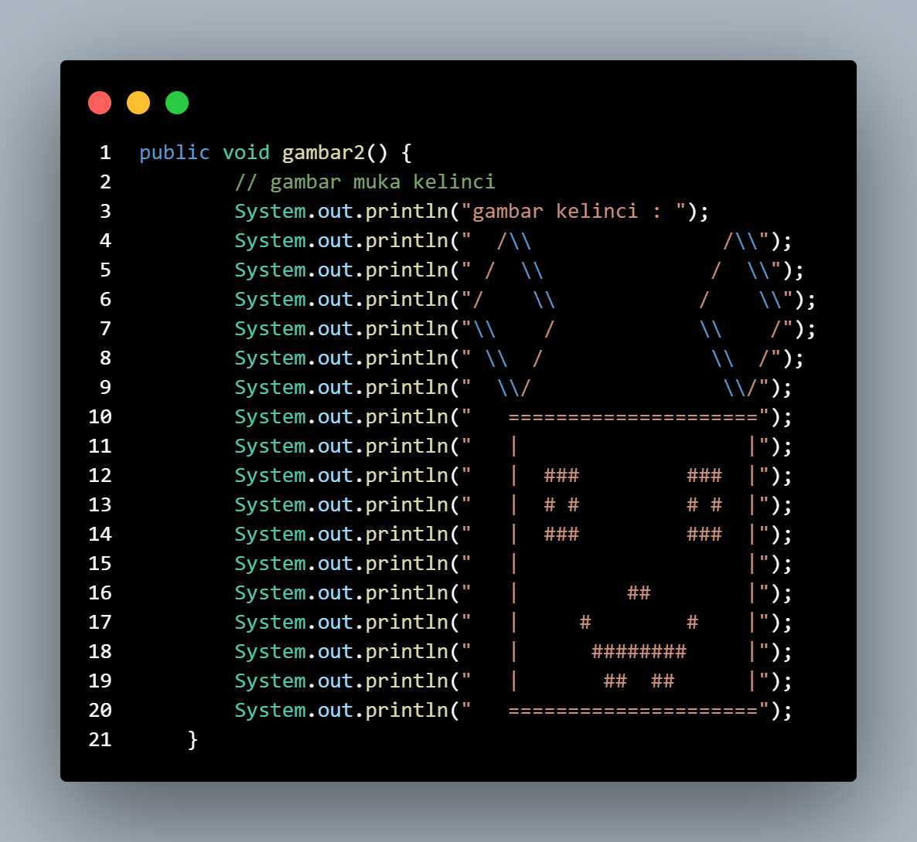

1. Code method The Snake Box Factory problem 3:

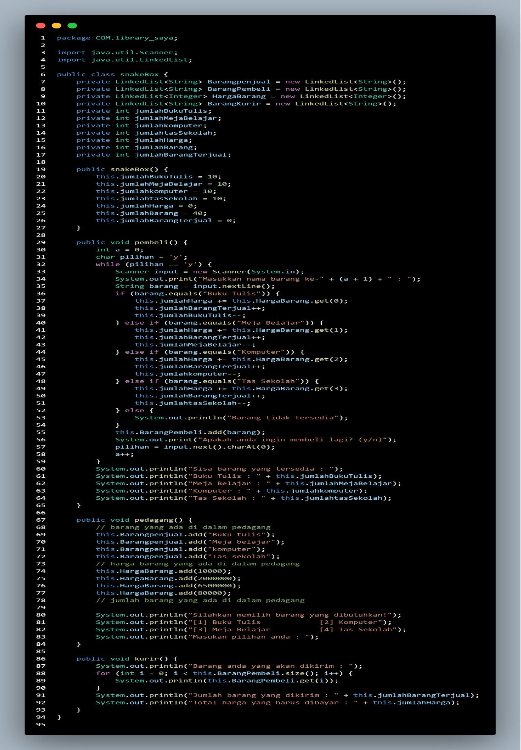

1. Method eksekusi atau menjalankan pogram:

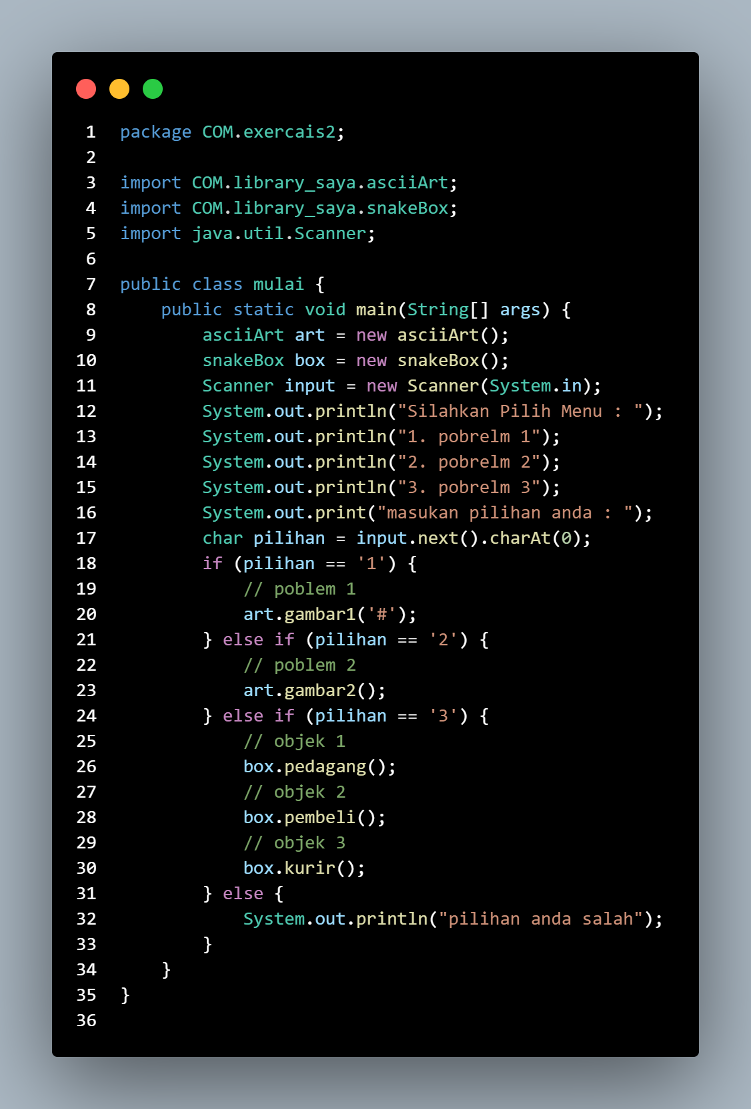

1. Output yang di dapatkan problem 1:

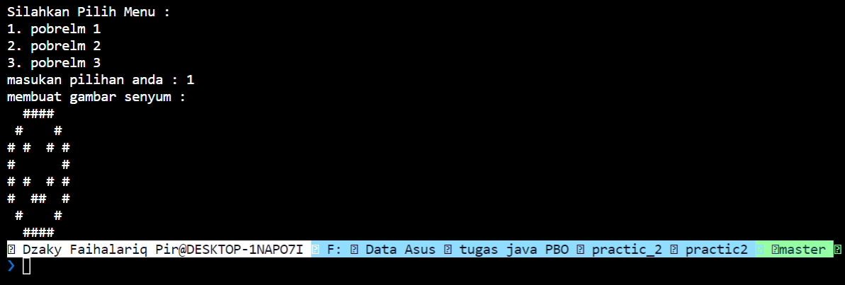

1. Output yang di dapatkan problem 2:

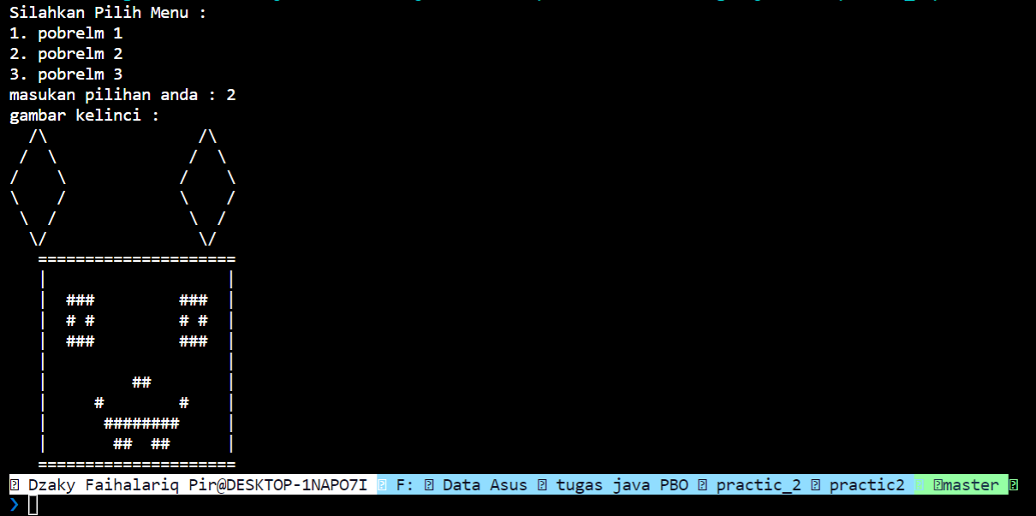

1. Output yang di dapatkan problem 3:

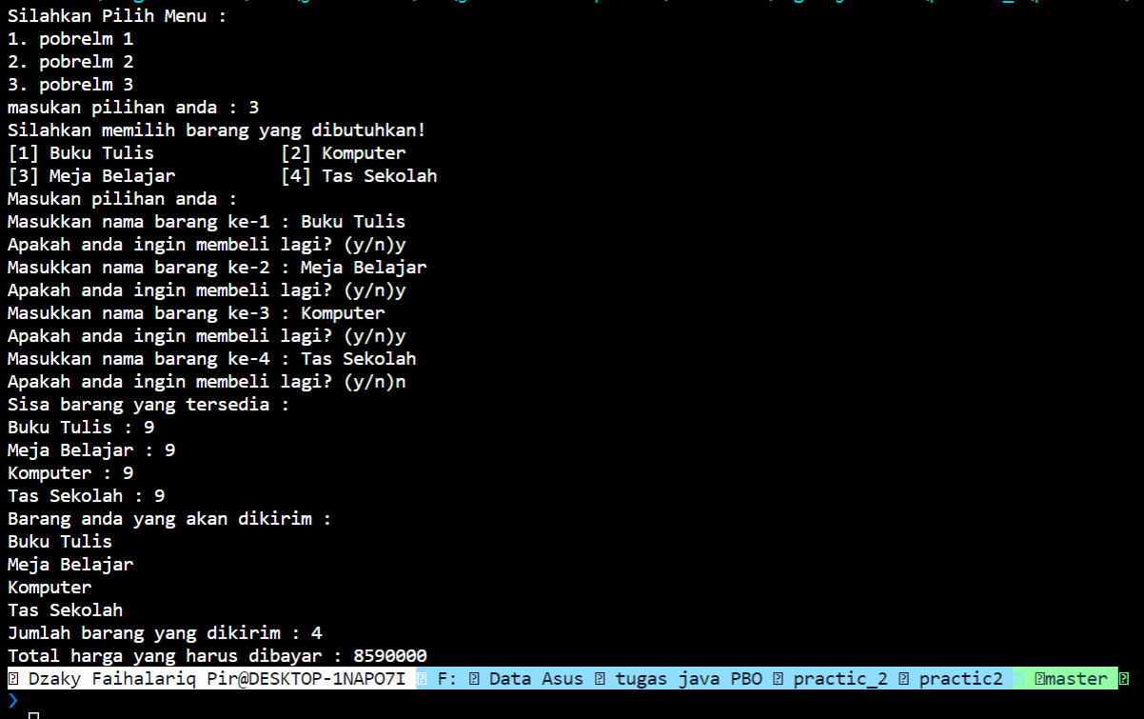

**Practice 3:**

Creating a JavaLibs Game.

Overview

Section 3 has shown you everything you’ll need to recreate a JavaLibs program, similar to the one you played at the beginning of the section. It may take a bit of thinking, but it’s a challenge you’re definitely ready for. Your program requirements are described below. Good luck, and have fun!

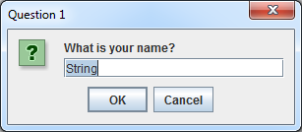

Tasks

Your goal is to create a program similar to JavaLibs. Write a story where certain parts of the resulting story

text are modified by the user’s input. Prompt the user for various inputs.

You may accept user any number of ways, including a JOptionPane, or Scanner input from the console.

However, choose only one method. Don’t use multiple methods of accepting input. Similarly, if you use

JOptionPane to get input, use JOptionPane to show the resulting story.

When you output your story, make sure your all your text is visible at the same time. It’s not ok for text to be

too long for your computer screen or output window. Your story will need to be spread across several lines

instead of being printed in one giant line of output. This helps keep your output clean and your program more

user friendly.

It’s ok for your program to crash if the user inputs inappropriate data. In other words, It’s ok if your program

crashes because you’ve expected the user to input a number, when they’ve instead input a String. We’ll

cover exception handling later in the course.

Your program must also do the following:

• Accept at least 1 input, to be parsed as a String

• Accept at least 1 input, to be parsed as an int

• Accept at least 1 input, to be parsed as a double

• Use at least 1 input in a question for the user

• Do math with at least 1 int input

• Do math with at least 1 double input

• Accept at least 10 total inputs

It’s ok for this problem set to write your entire program within the main method.

Jawab :

Sourc code 1 :

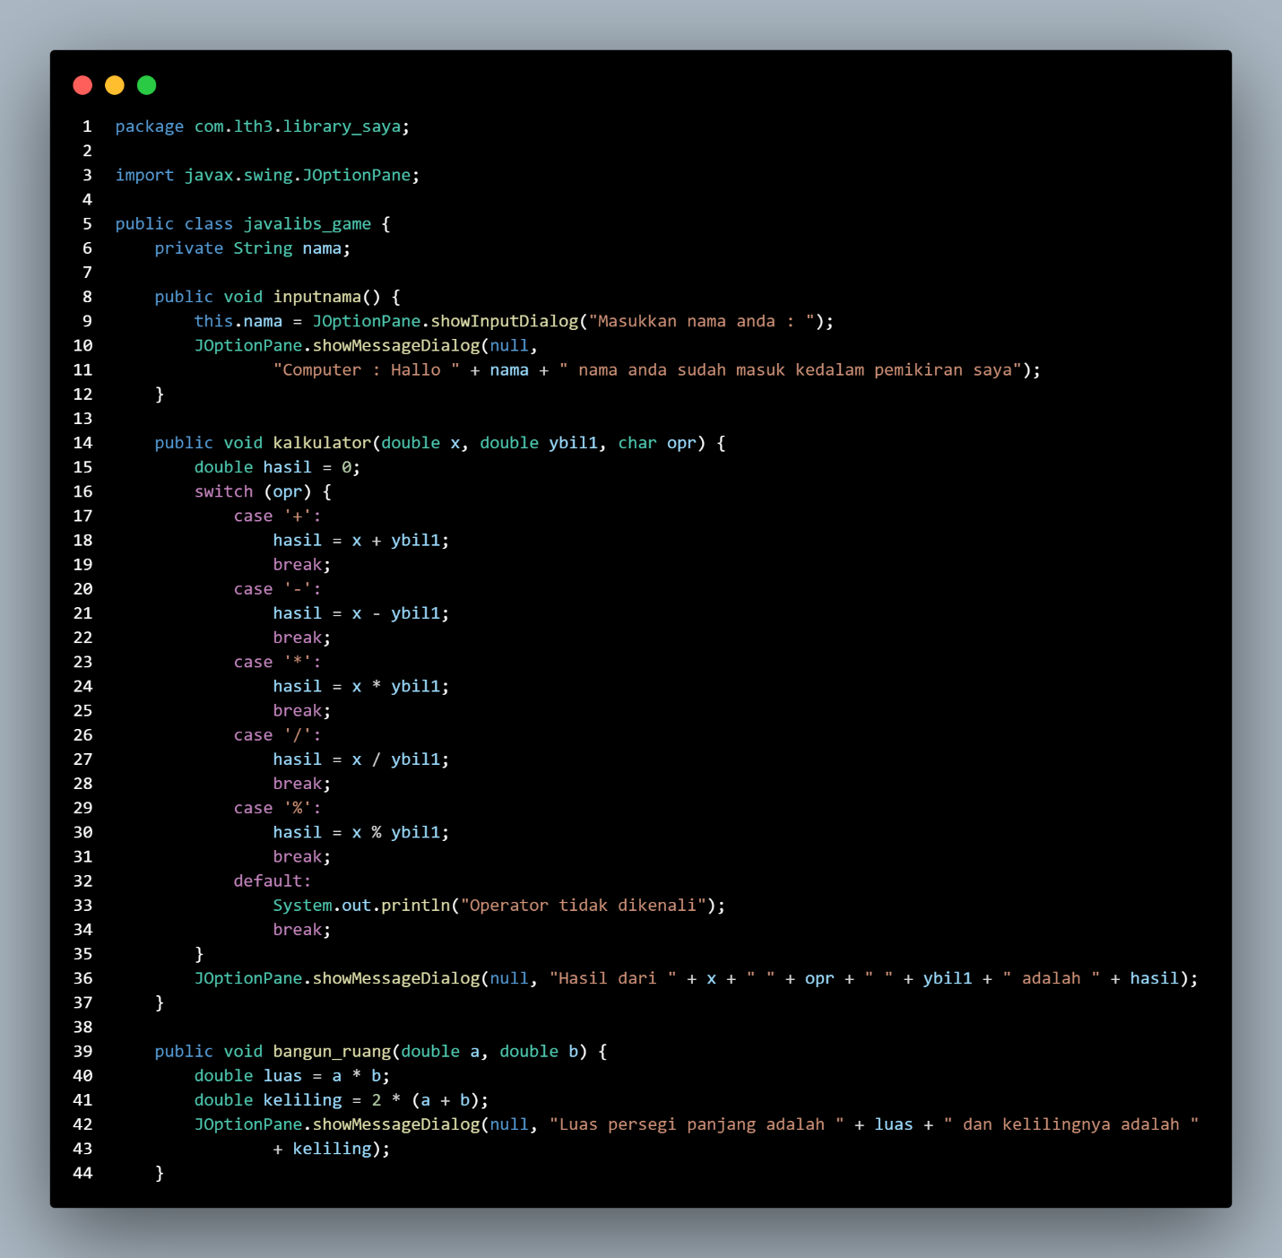

Sourc code 2 :

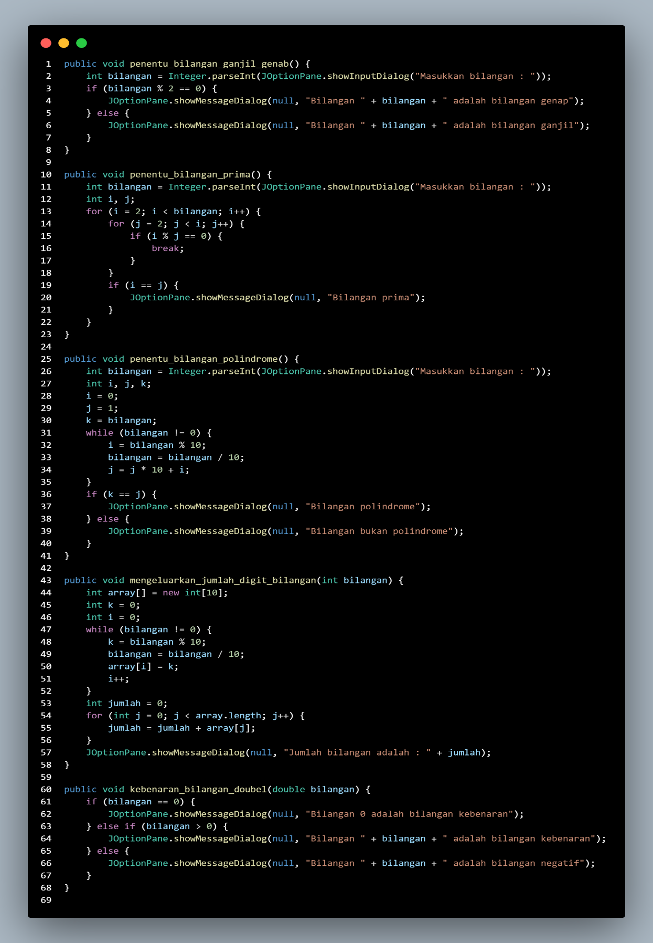

Sourc code 3:

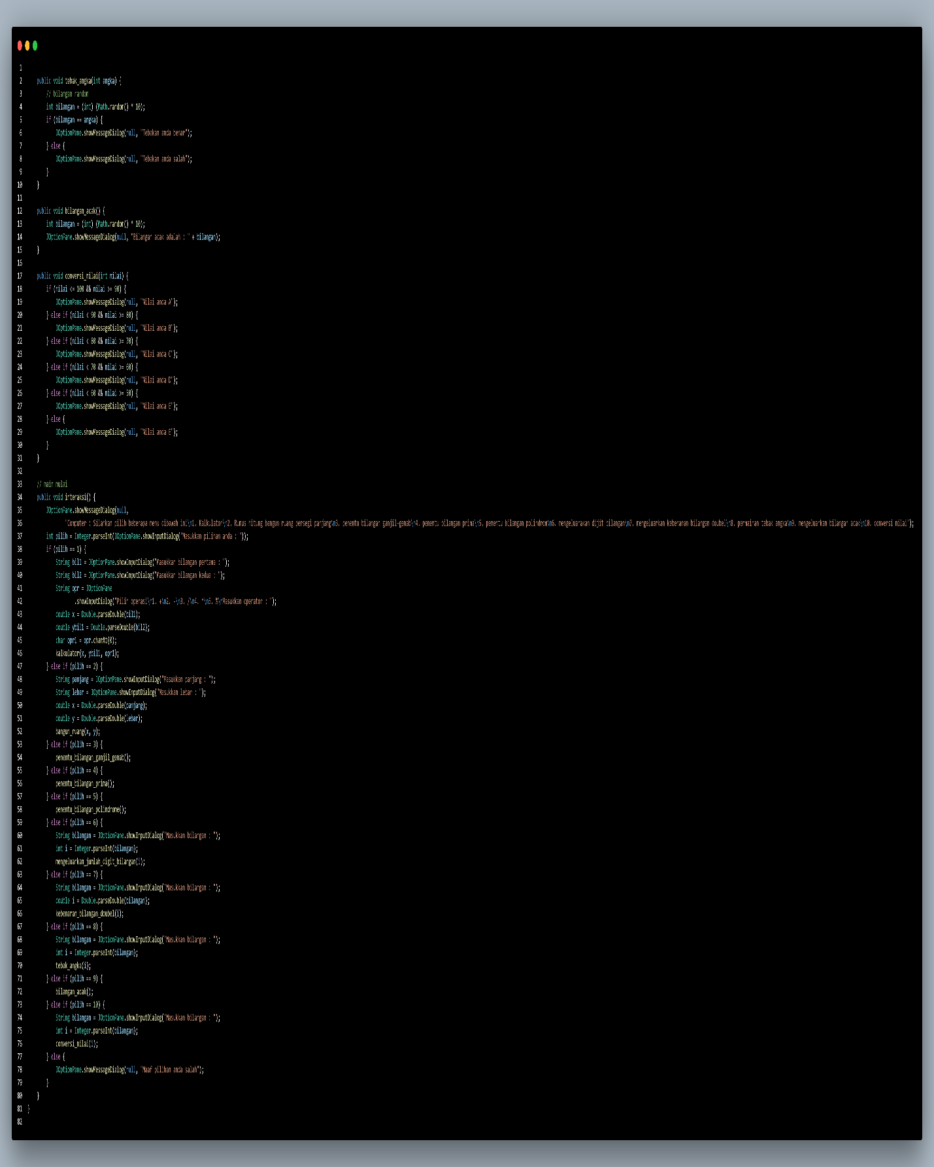

Sourc code eksekusi pogram:

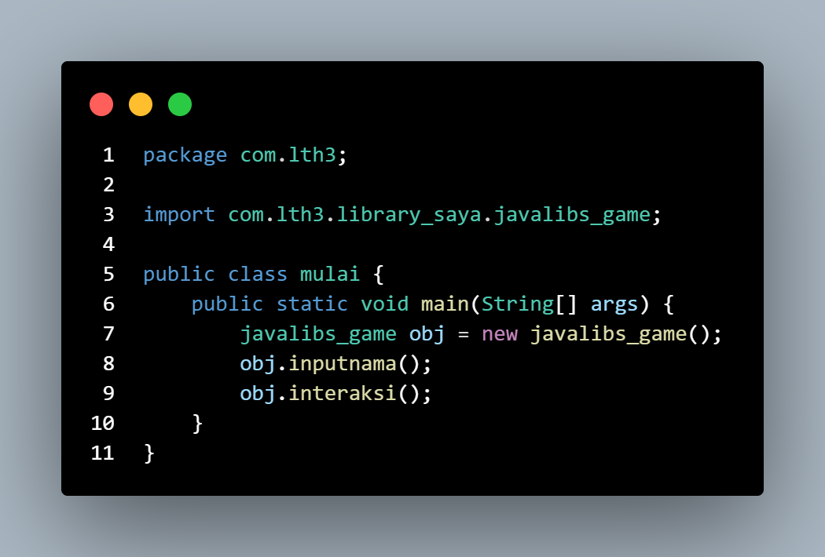

Output yang di dapatkan:

1. Bagian 1

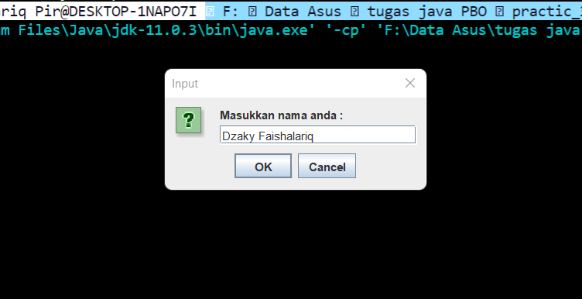

1. Bagian 2

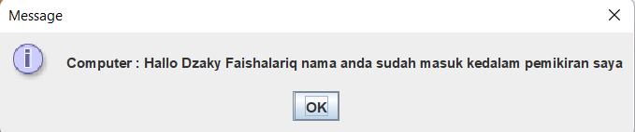

1. Bagian 3:

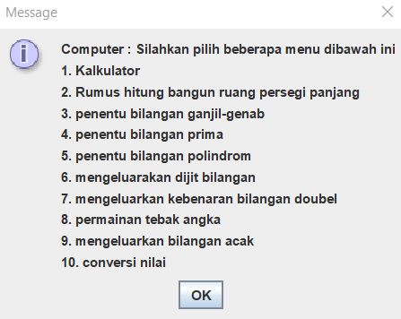

1. Bagian 4

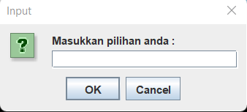

1. Bagian 5

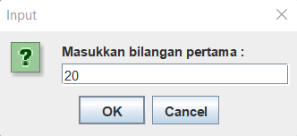

1. Bagian 6

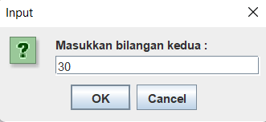

1. Bagian 7

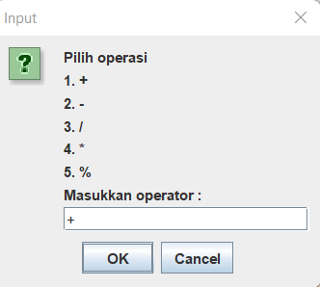

1. Bagian 8

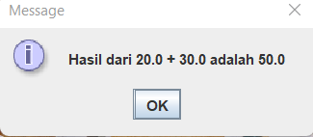

**Practice 4:**

1. Writing methods

Overview

In this practice, you will write methods that return values for the following scenarios:

1. Converts given temperature in Fahrenheit to Celsius.
2. Computes the hypotenuse length of a triangle given its side lengths
3. Simulate the rolling of two 6-sided dice and display their sum.

Jawab:

Sourc code

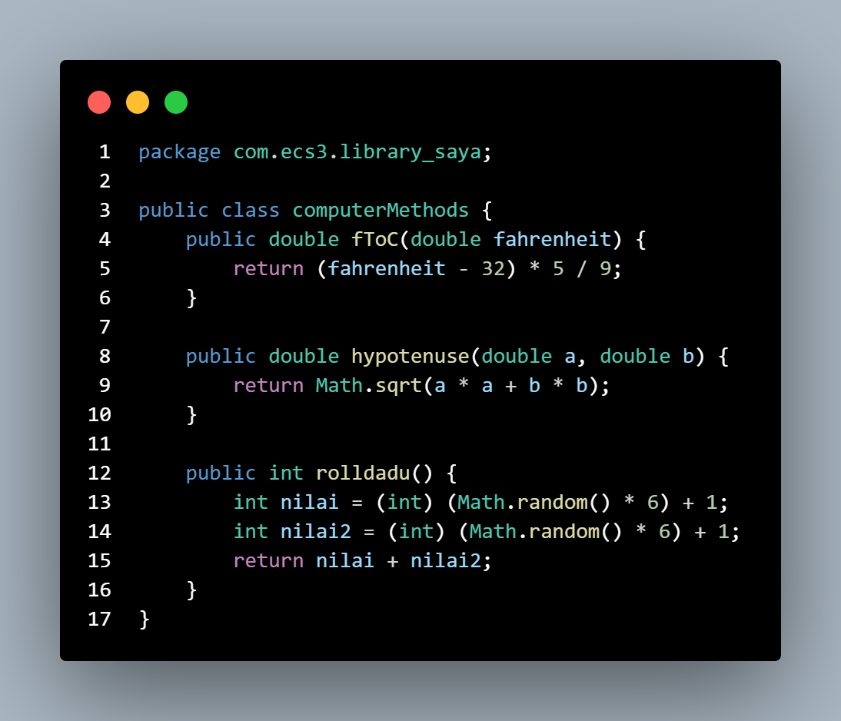

Sourc code esekusinya:

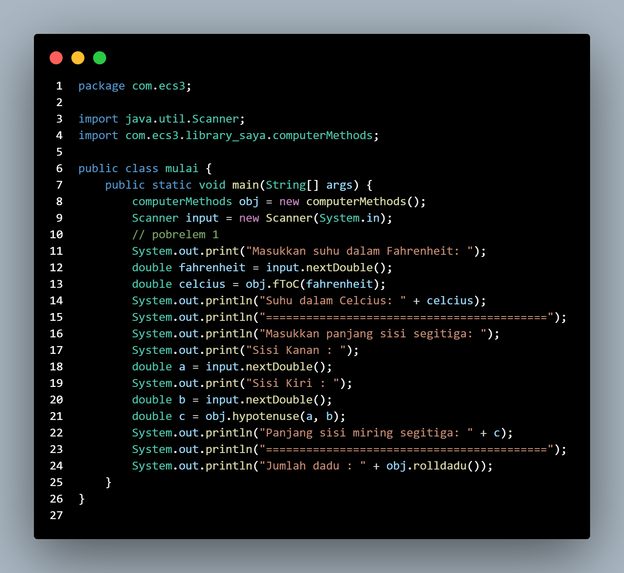

Output:

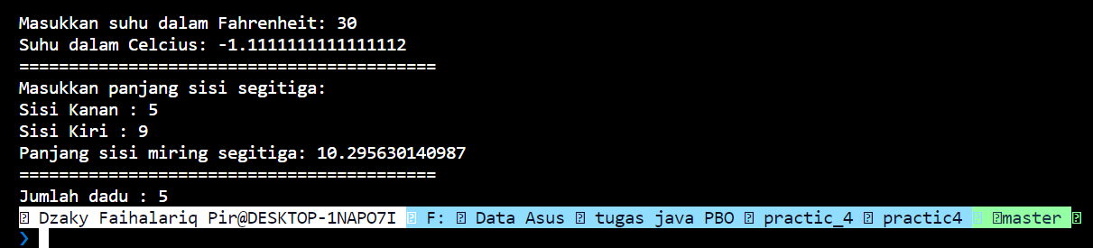

1. Task

You must implement the following:

Write a second java file, TestClass.java and perform the following:

Add a main method, in the main method:

Create an instance of ComputeMethods and invoke the methods defined in

ComputeMethods.java on this instance and display their results.

Expected Output:

Temp in celsius is 38.00000000000001

Hypotenuse is 10.816653826391969

The sum of the dice values is 9

The ProblemSet4_1 project is available to help you get started

Jawab :

Sourc code nya:

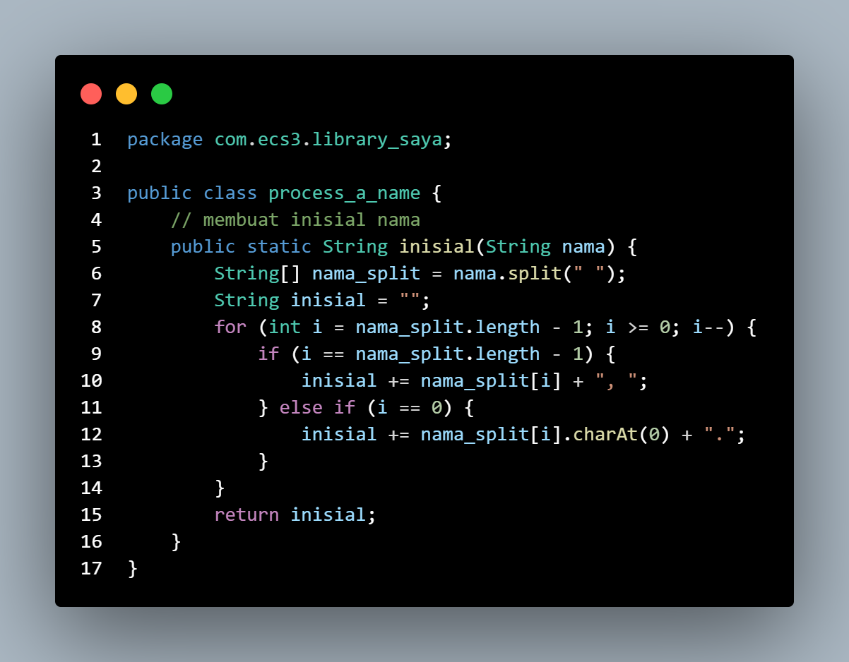

Sourc code esekusinya

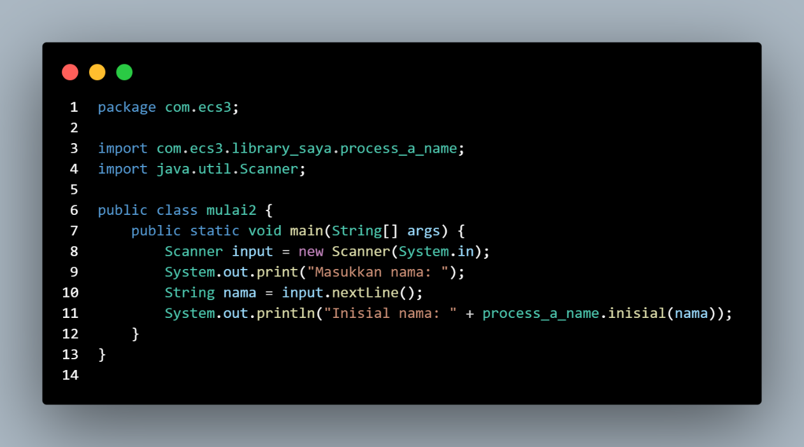

Outputnya :



**Practice 5**

1. Determining color in the visible spectrum

Overview

Write an interactive Java program, ColorRange.java, which when given a wavelength in nanometers will return the corresponding color in the visible spectrum.

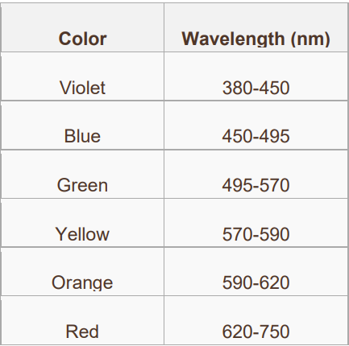

Task:

You must implement the following using a suitable if decision statement.

1. Prompt the user to enter the wavelength, the wavelength should be of type double.
2. For each range (e.g. 380-450) the number on the left is included in the range, but the number on the right is not included in the range
3. If the input value is not found on the visible spectrum then state that the wavelength is not within the visible spectrum.
4. Expected Output:

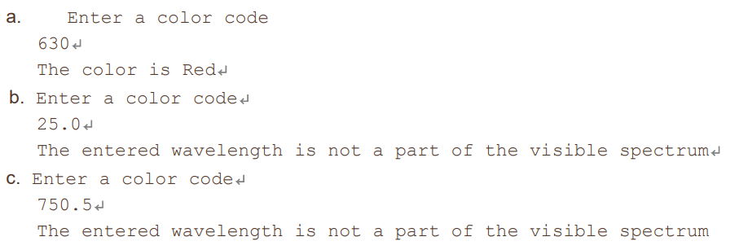

Jawab :

Sourc code nya:

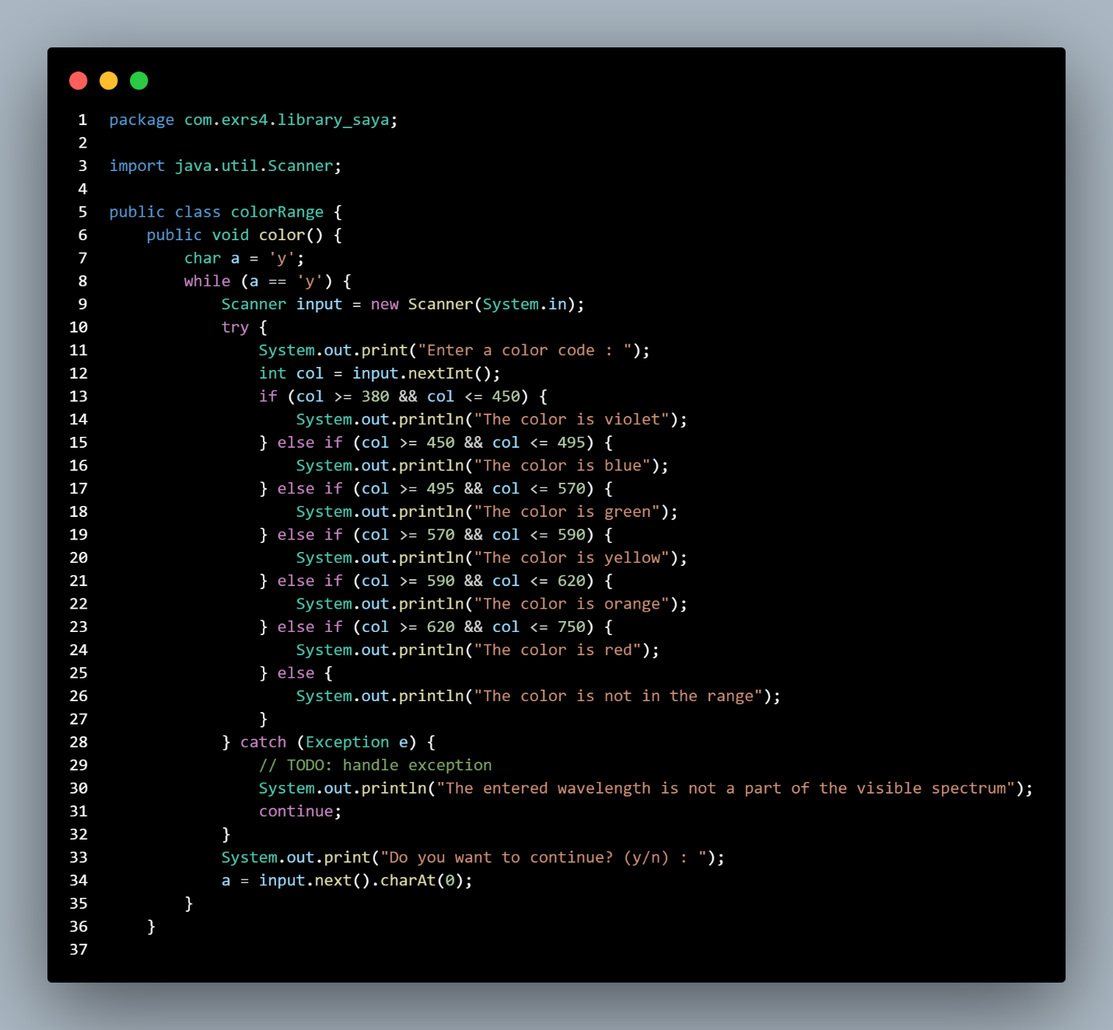

1. Determining the next color for a stop light

Overview

The normal behavior for a stop light is to cycle from Red to Green to Yellow to Red (and continues with this pattern). Write a java program StopLight.java, which will determine the next color of a stop light in this pattern, Red to Green to Yellow to Red based on the current stop light provided by the user.

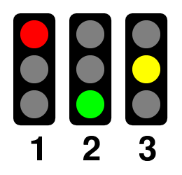

Task

You must implement the following using a suitable if decision statement.

1. Have the user enter the value for the currentColor.

2. Compute the next color stop light based on the currentColor.

3. Alert the user for any invalid value of color.

Expected Output:

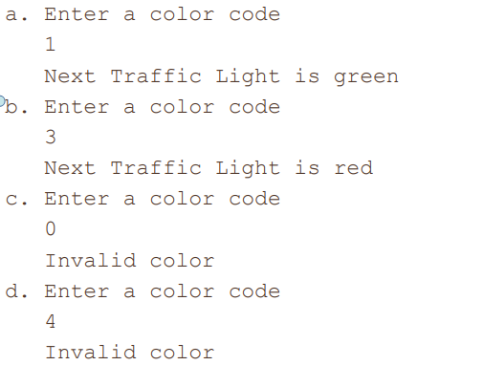

Jawab :

Sourc code nya:

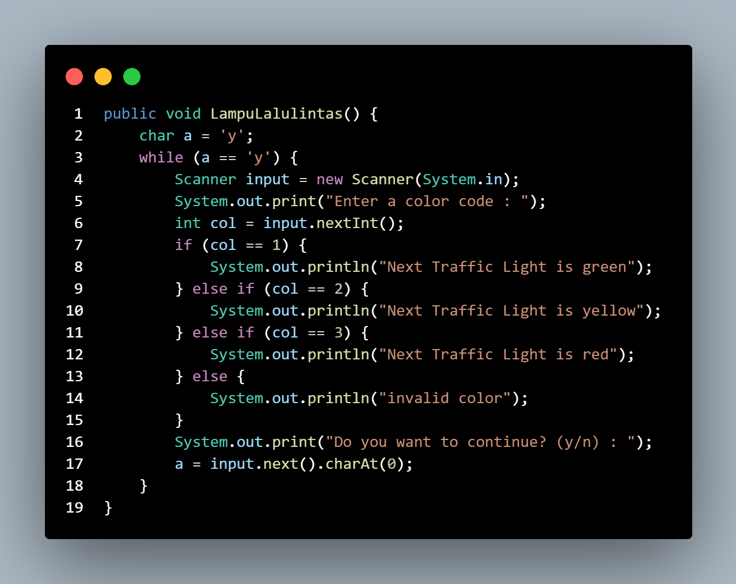

1. Determining the next color for a stop light using switch

Overview

Re-write practice 5-2 using switch statement.



Task

Implement practice 5-2 using switch statement and ensure the program alert users if they’ve entered any invalid value.

Jawab :

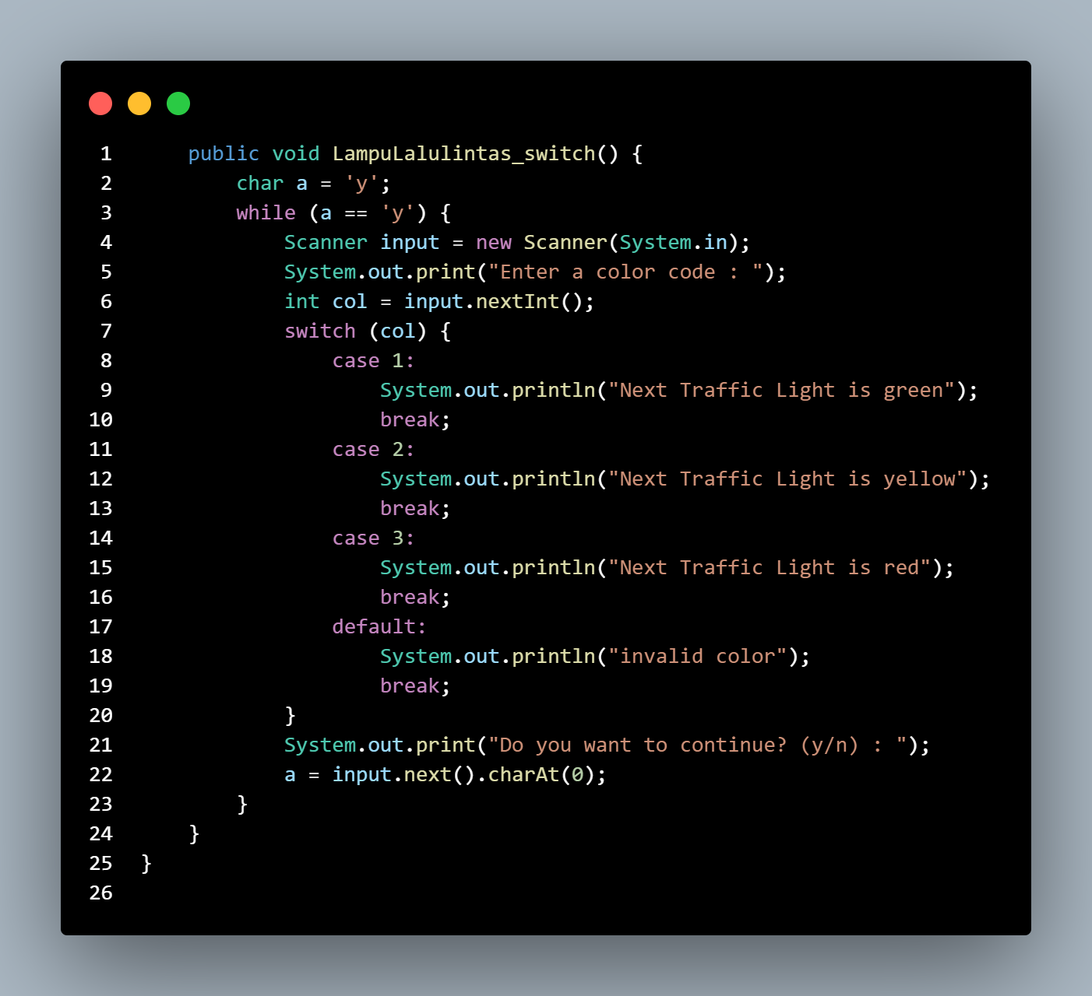

Sourc code eksekusinya :

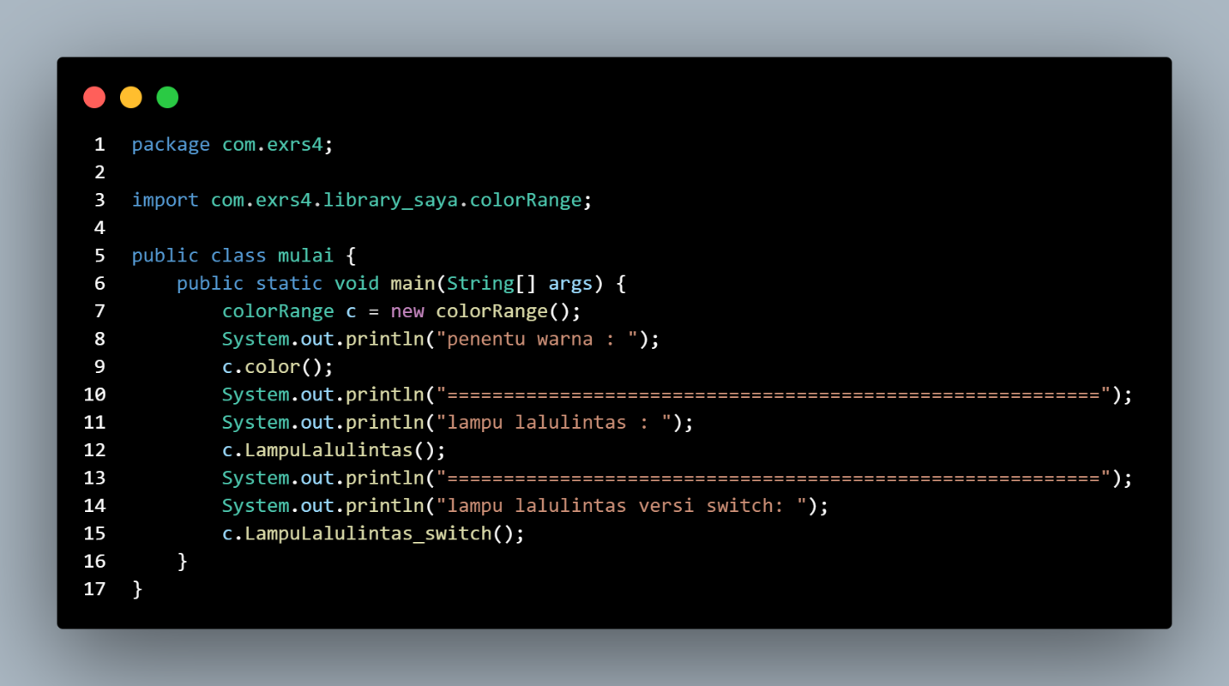

Outputnya dari ketiga jawaban tersebut:

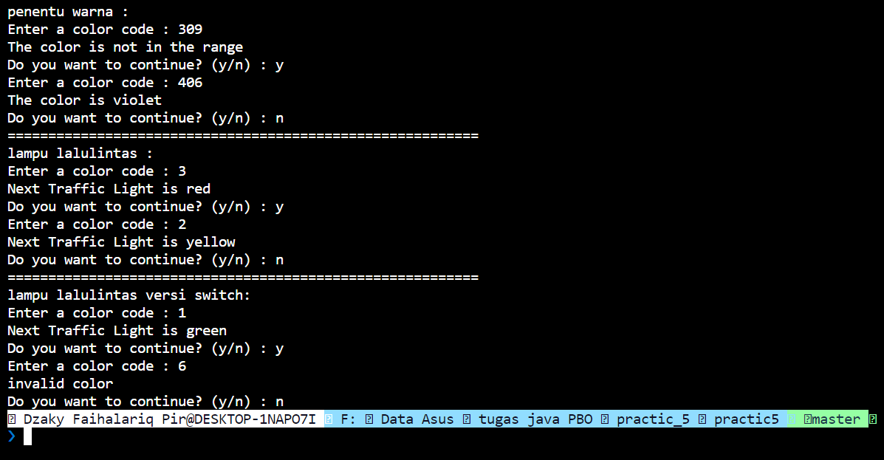

**Practice 6**

1. Problem 1: Validate a Bank PIN

Overview

Develop a java program to validate bank PIN of a customer. Use a while loop to repeat code until a valid PIN is entered.

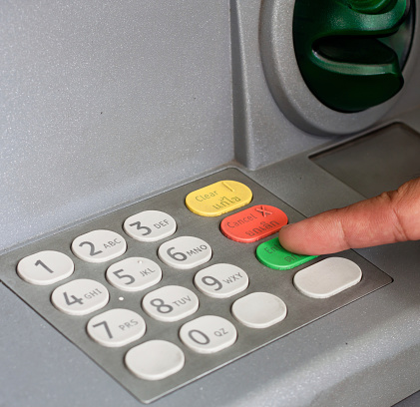

Task

1. Declare a valid integer PIN.

2. Prompt the user to enter the PIN.

3. In a while loop, perform the following steps:

o Compare the user-entered PIN with the already declared PIN.

o If the entered PIN is not the same, prompt the user to enter the PIN again.

o Repeat the loop until the correct PIN is entered.

4. Print a message confirming that the correct PIN has been entered and that the user now has access to their account.

Jawab :

Sourc code nya:

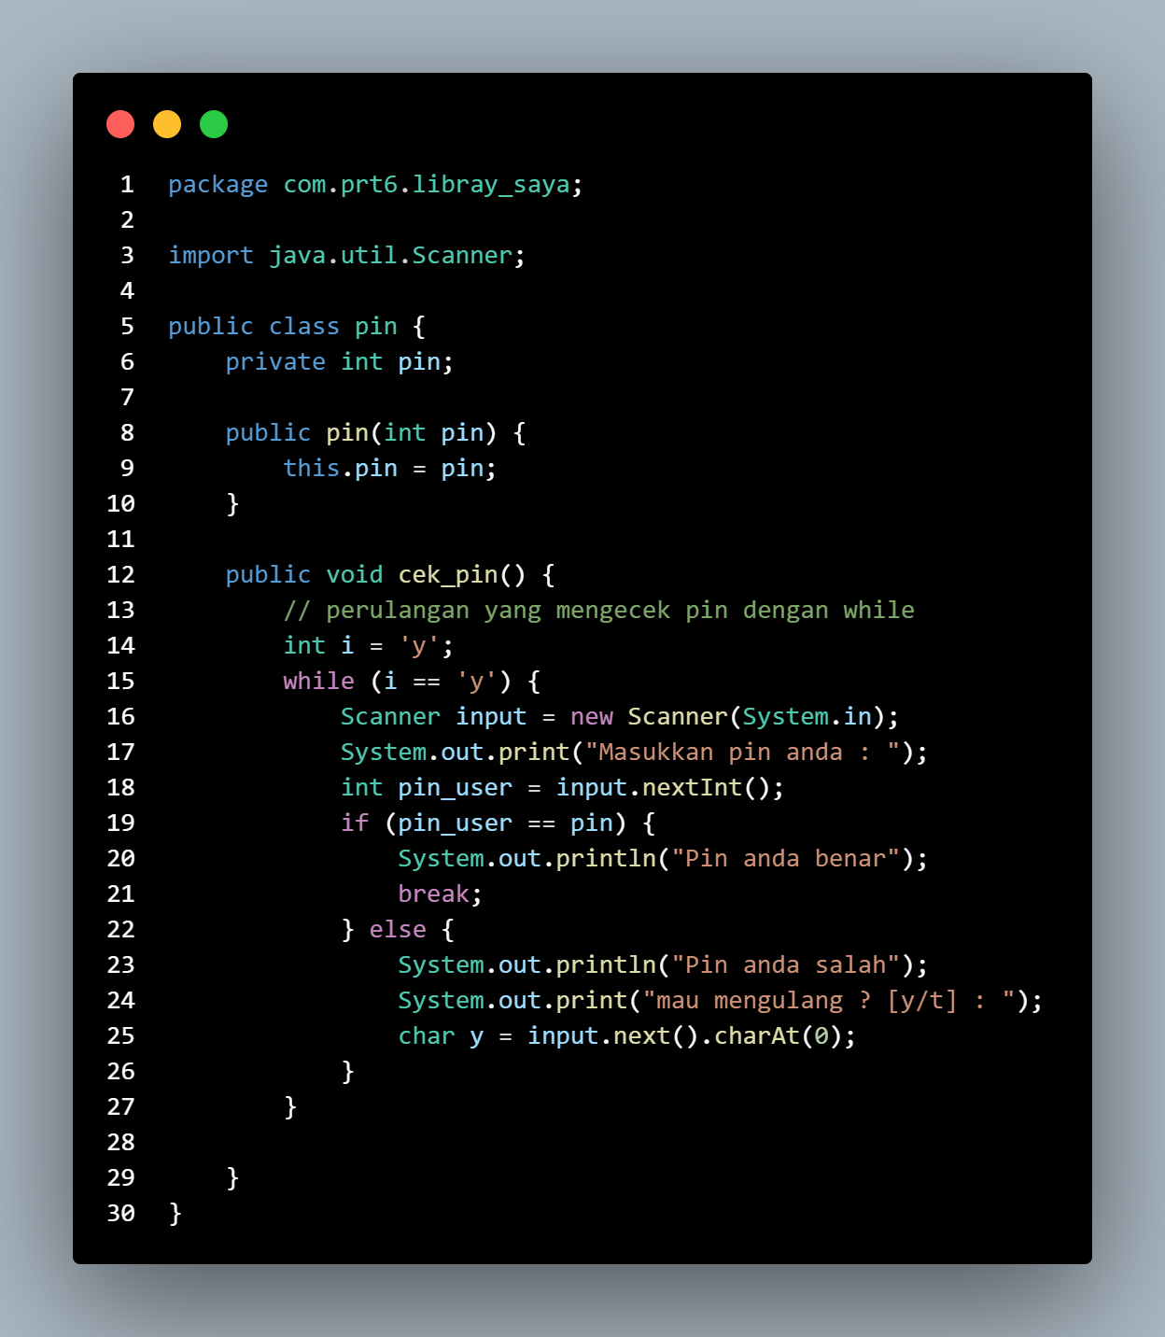

1. Problem 2: Displaying Multiples of a Number

Overview

Develop a java program to calculate the multiples of a given number using a for loop. Task Have the user enter a number, and then use a for loop to display all the multiples of that number from 1 to 12.

Expected Output:

Jawab :

Sourc codenya:

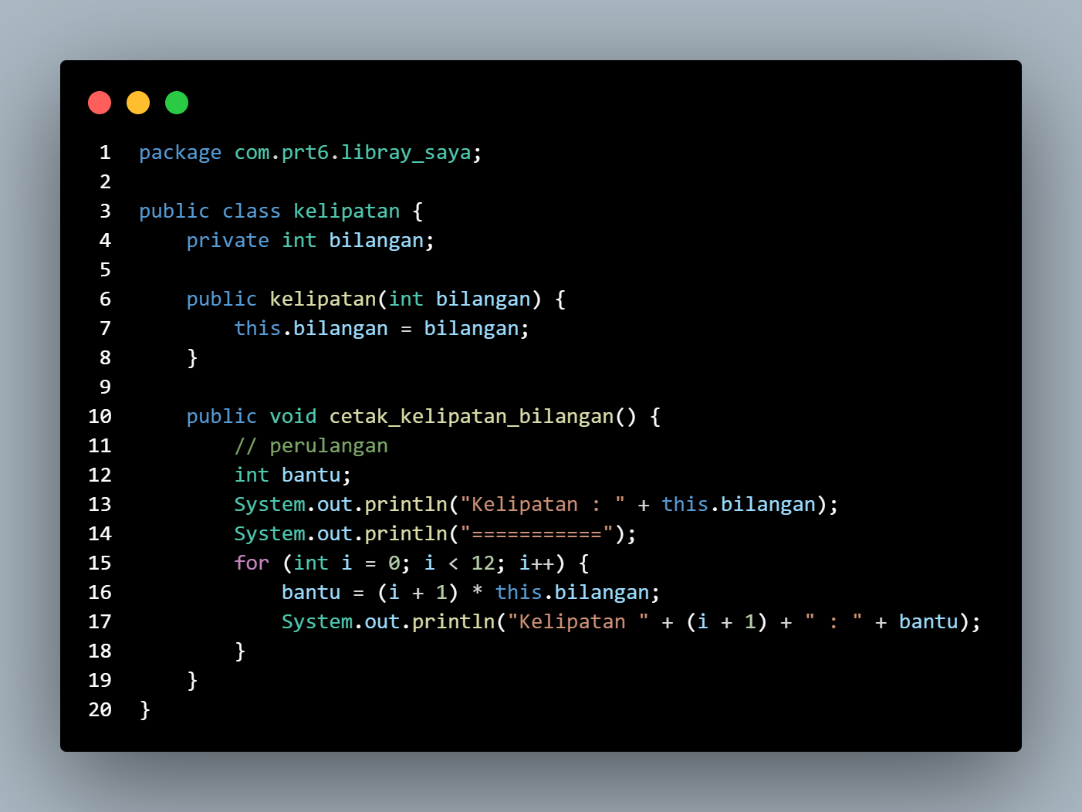

1. Problem 3: Programmatic ASCII Art

Overview

Using text to create a picture is known as ASCII art. In section 2, we made an ASCII art cat. This required us to type every character in the art we wanted to create. In this practice, you’ll find a way to draw basic shapes programmatically in customizable sizes.

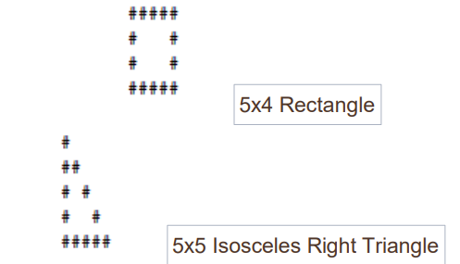

Task

Complete the following two methods in LoopShape.java:

• createRectangle(): This method accepts two arguments for width and height which should be used to print a rectangle

• createTriangle(): This method accepts one argument for the size of a leg, which should be used to print an isosceles right triangle

Try changing the value of the arguments you’re supplying these two methods from the main method. Make sure your program can successfully draw each shape to a custom size. Additionally, your program must:

• Refuse to draw shapes with any dimension less than 1

• Be able to draw shapes with any dimension equal to 1 (a 1x1 shape should print just a single character)

If the problem seems difficult, remember to break it into smaller challenges such as:

• How do I print a single line that is a variable number of “#” characters wide?

• How do I create a String that begins and ends with a “#”, but has a variable number of spaces in between?

Finishing each smaller challenge is an accomplishment. This problem is as much about understanding loops as it’s about understanding how to break a big problem into smaller tasks.

The knowledge you’ve gained in this section on loops will be very helpful in completing this program. You’re

free to use whichever type of loop statements you feel would be best. You’ll also need to remember a few

concepts from previous sections.

The ProblemSet6_3 project is available to help you get started

Jawab :

Ourc codenya :

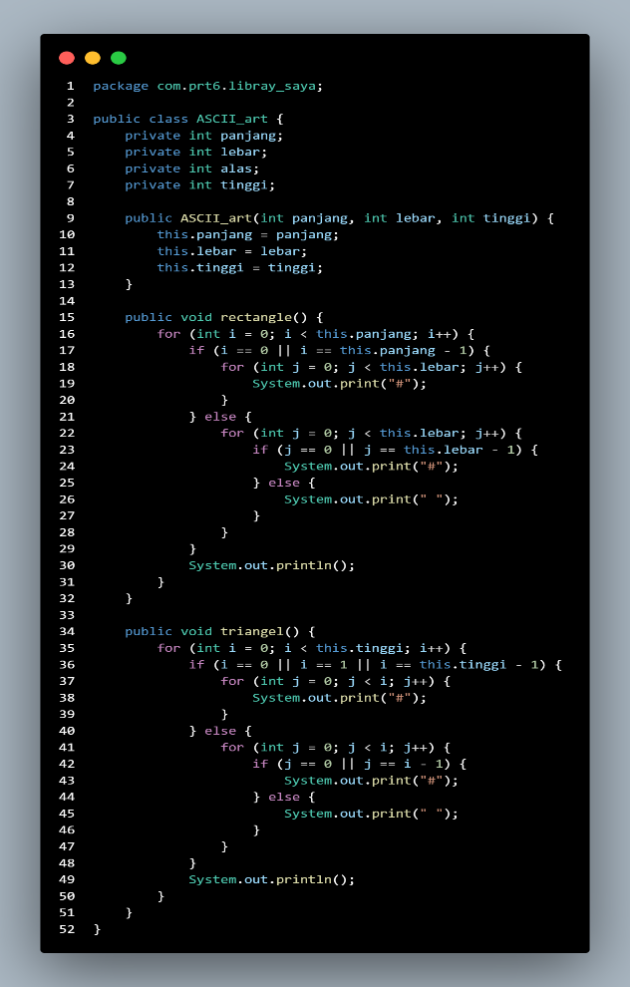

Output yang di hasilkan:

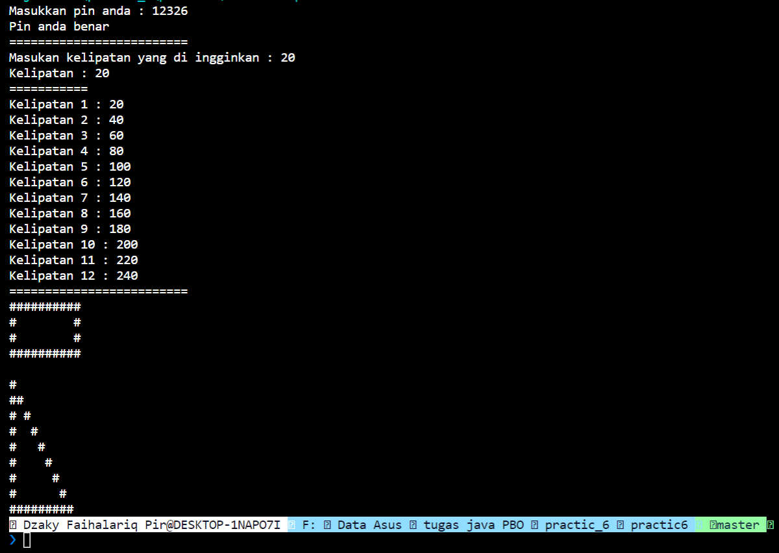

**Practice 7**

Date Night at the Arcade

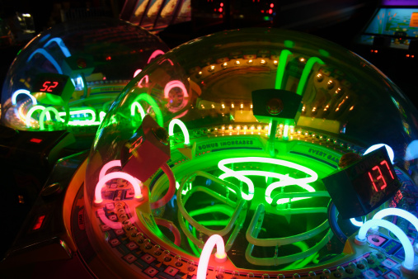

Overview

Tonight is date night at the arcade. After great evening of playing games and winning prizes, you and your date can’t help wondering “How are these machines programmed?”. You discuss possible designs on the subway back to campus. You enjoy the rest of the night romantically programming your ideas together. You’ve made several observations about the arcade. A terminal is used to convert money into game credits. Credits are loaded onto plastic game cards. This data is stored in a card’s magnetic strip. Cards may be swiped at any arcade game through the game’s magnetic card reader. Games subtract credits from a card, but awards tickets. Tickets are also stored on a card’s magnetic strip. Tickets may be exchanged for prizes at the terminal. The terminal is also used to check a card’s credit balance and ticket count, and to transfer credits or tickets between cards.

Tasks

Write a Java program that models the properties, behaviors, and interactions of objects at the arcade. You’ll also need a test class that contains a main method. Use the main method to model actions that would drive the program such as object instantiations and card swipes. All fields must be private. Provide getter and any necessary setter methods.

Cards

The magnetic strip on game cards offers limited storage space and zero computing power. Cards store information about their current credit balance, ticket balance, and card number. Neither balance should ever be negative. Individual cards are incapable of performing calculations, including simple addition, or realizing that their balances could go negative.

Every card is created with a unique integer identification number. Although each individual card is incapable of simple addition, it’s still possible to perform calculations with properties that belong to all cards.

Jawab :

Sourc code:

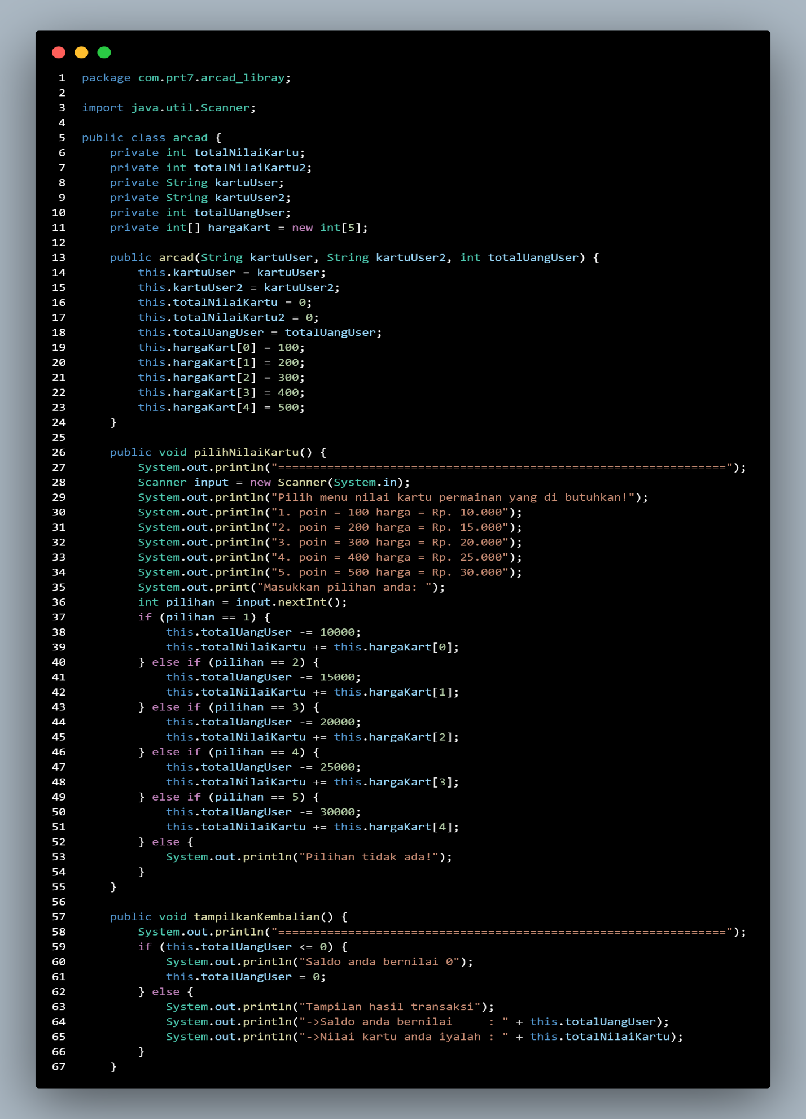

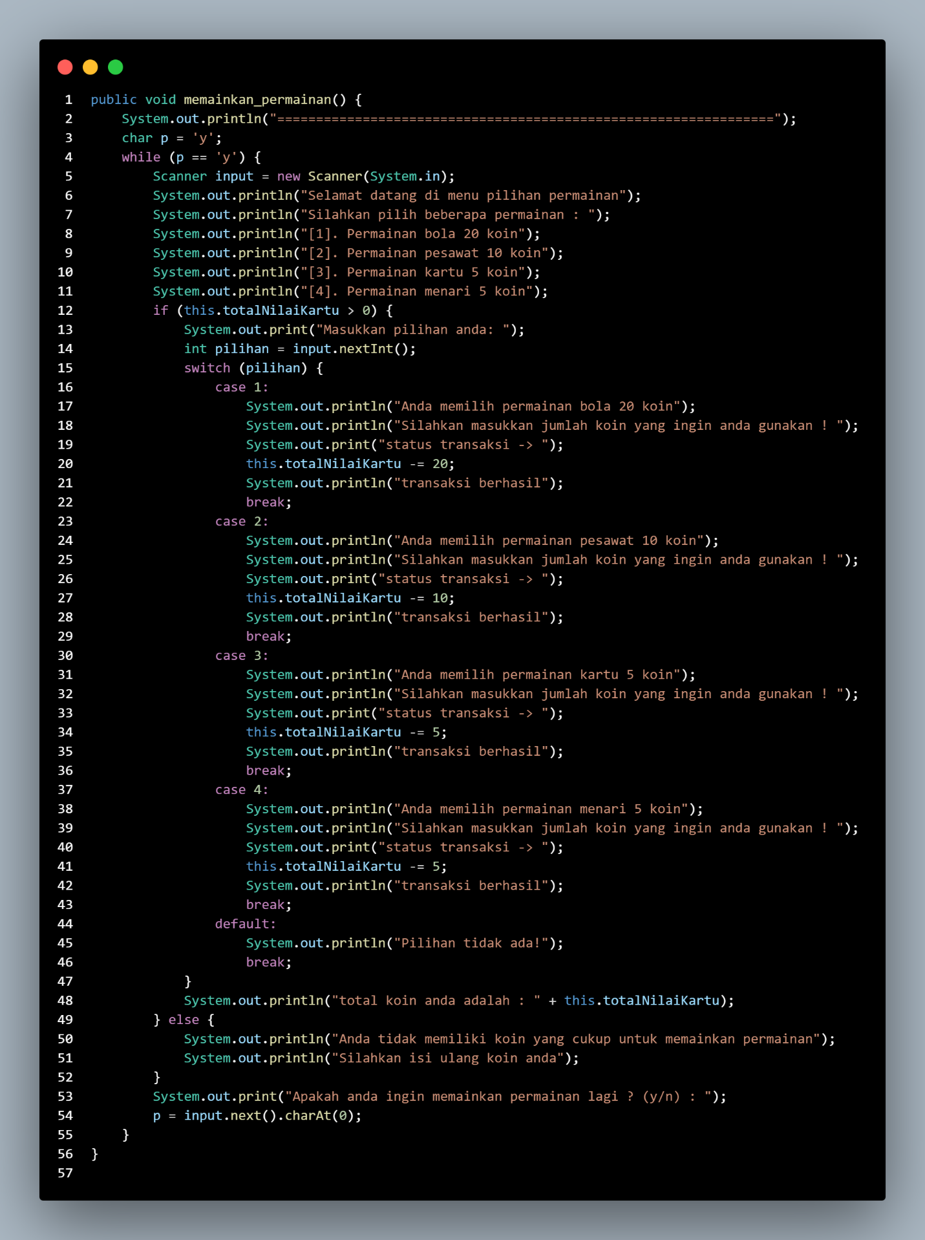

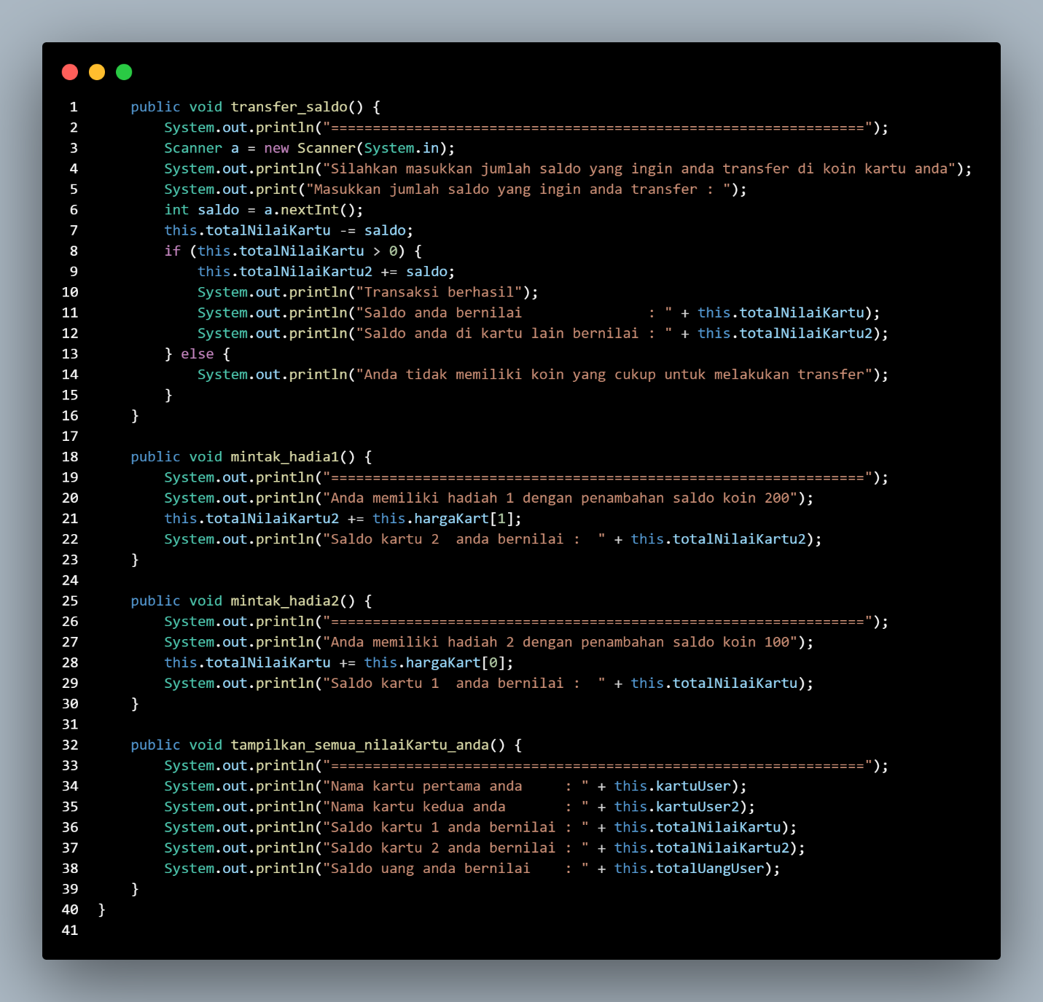

Code esekusinya :

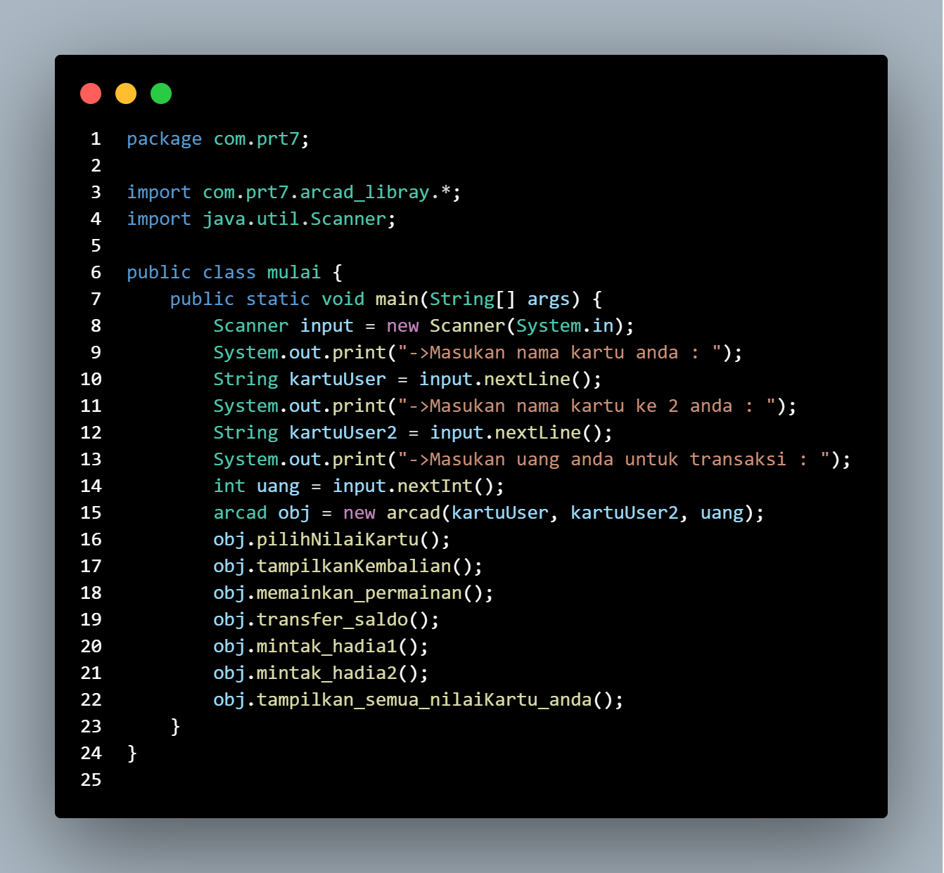

Outputnya :

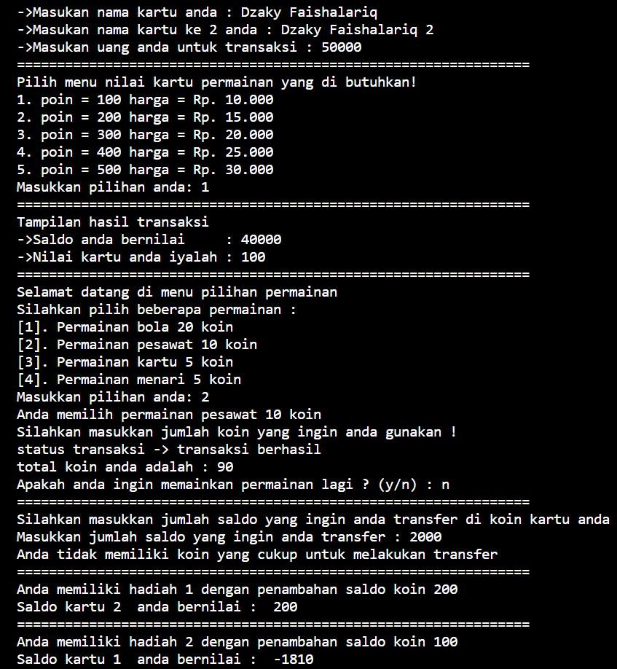

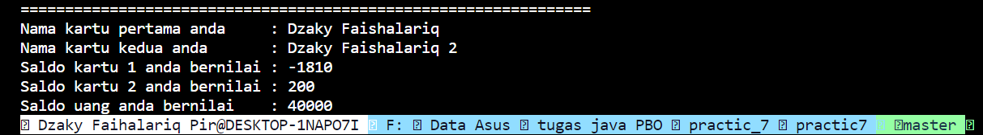

**Practice 8**

The Soccer League



Overview

It’s been a brutally cold and snowy winter. None of your friends have wanted to play soccer. But now that spring has arrived, another season of the league can begin. Your challenge is to write a program that models a soccer league and keeps track of the season’s statistics. There are 4 teams in the league. Matchups are determined at random. 2 games are played every Tuesday, which allows every team to participate weekly. There is no set number of games per season. The season continues until winter arrives.

The league is very temperature-sensitive. Defenses are sluggish on hot days. Hotter days allow for the

possibility of more goals during a game. If the temperature is freezing, no games are played that week. If

there are 3 consecutive weeks of freezing temperatures, then winter has arrived and the season is over.

Tasks

Write a program that models a soccer league and keeps track of the season’s statistics. Carefully consider what data should be stored in an array and what data should be stored in an ArrayList. Design classes with fields and methods based on the description of the league. You’ll also need a test class that contains a main method. All fields must be private. Provide any necessary getters and setters.TeamsEach team has a name. The program should also keep track of each team’s win-total, loss-total, tie-total, total goals scored, and total goals allowed. Create an array of teams that the scheduler will manage. Print each team’s statistics when the season ends.

GamesIn a game, it’s important to note each team’s name, each team’s score, and the temperature that day. Number each game with integer ID number. This number increases as each game is played. Keep track of every game played this season. This class stores an ArrayList of all games as a field.Your program should determine scores at random. The maximum number of goals any one team can score should increase proportionally with the temperature. But make sure these numbers are somewhat reasonable.When the season ends, print the statistics of each game. Print the hottest temperature and average temperature for the season.

Jawab:

Sourc code nya:

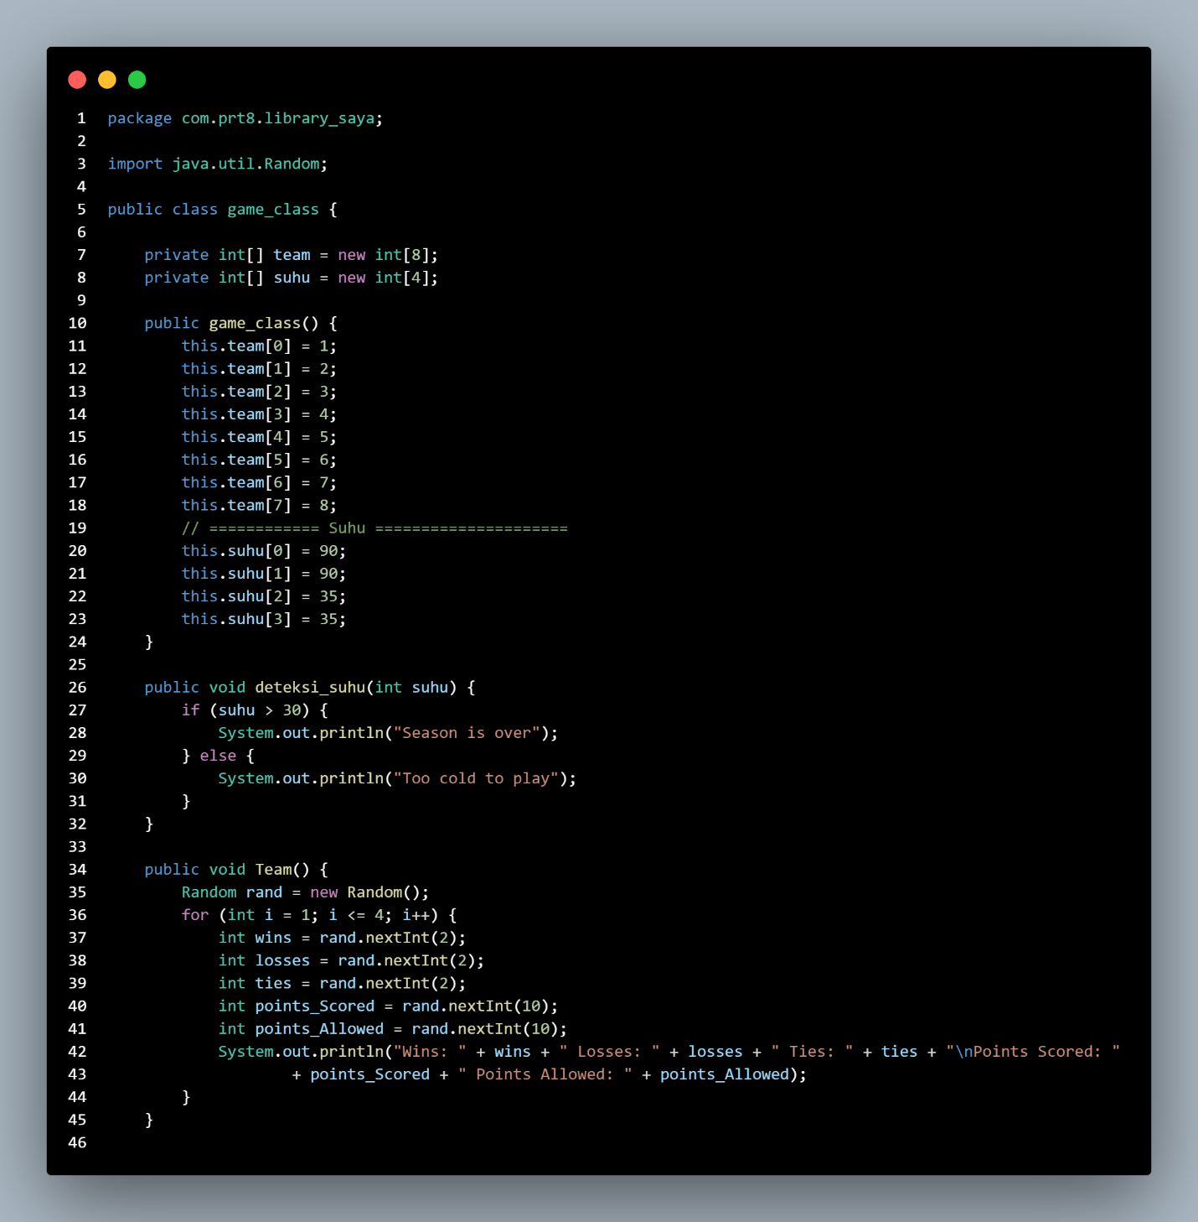

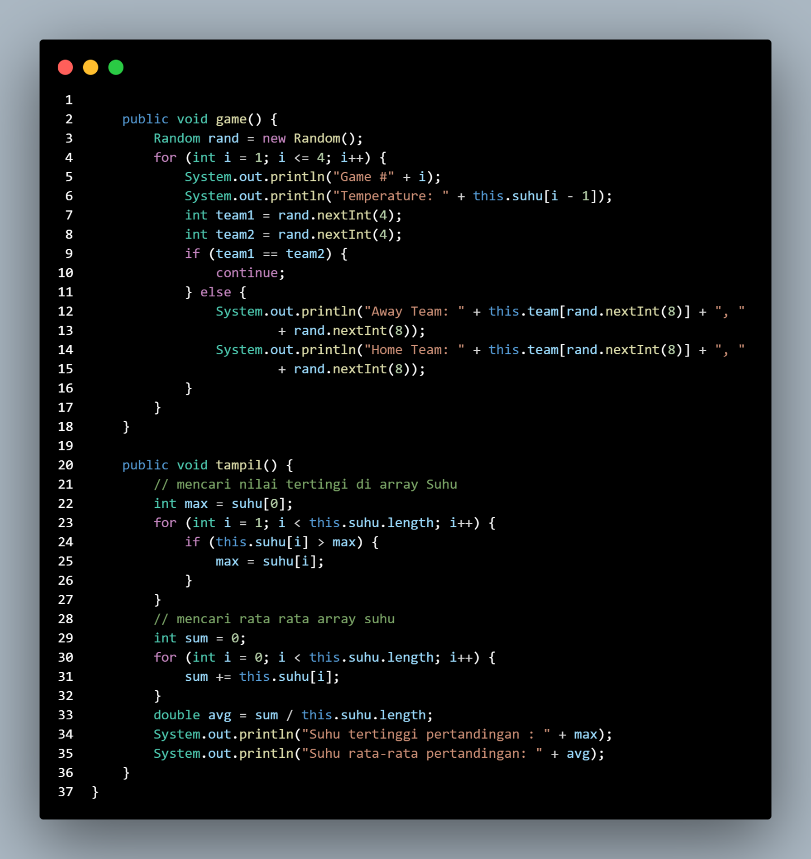

Sourc code eksekusi nya:

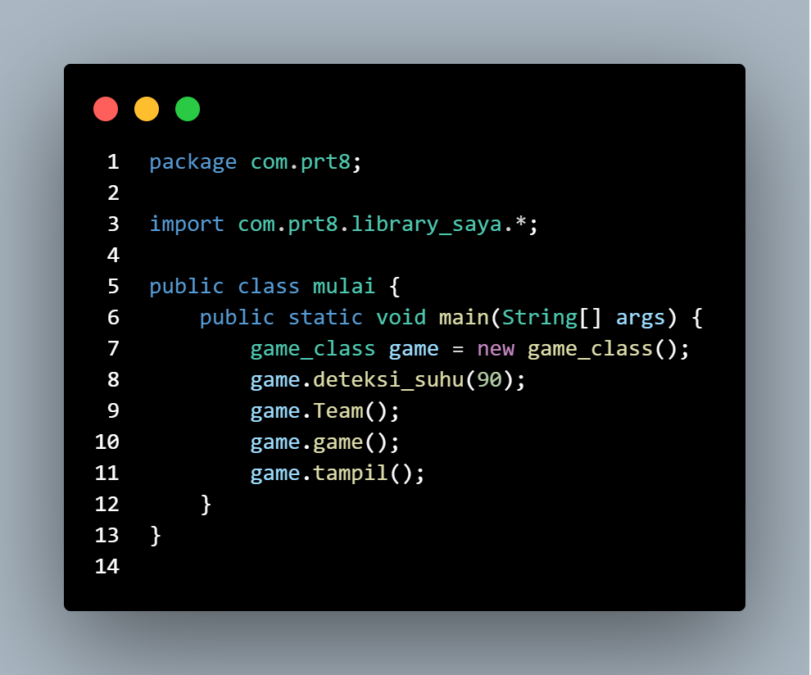

Outputnya :

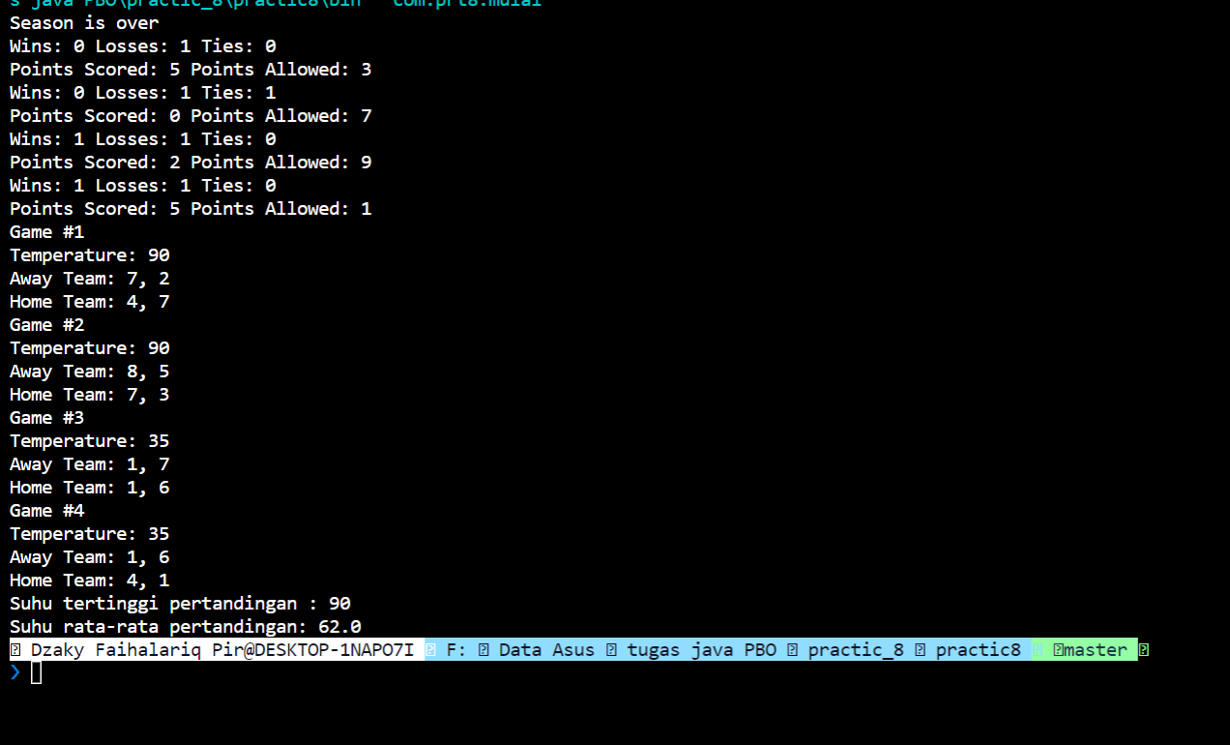

**Practice 9**

Finding a Central Location

Overview

Have you ever wondered where the most centrally located point on campus is? How about a centrally located point between you and a number of your friends? In this Problem Set, you’ll write a JavaFX program that answers these questions visually.

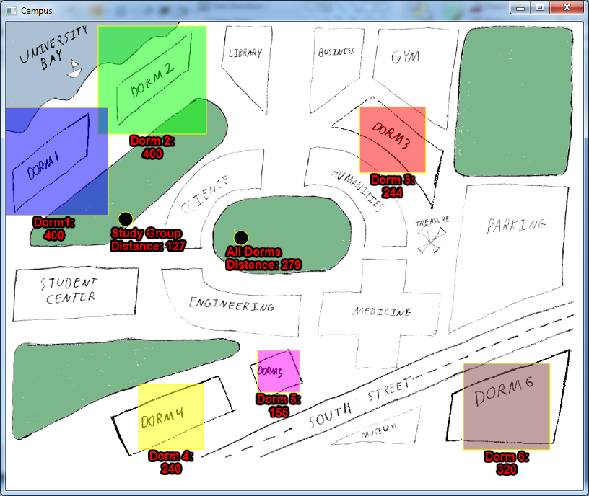

Tasks

Your goal is to create the CampusMap program that uses your map of campus, dorm names, dorm populations, and your group of friends. You’re welcome to design your own campus map (this is your background graphic). You’ll have to design your own campus map if your actual campus has fewer than 3 dorms, otherwise this Problem Set wouldn’t be too interesting

The Dorms

Choose a way to visually represent dorms. The name and population of a dorm must also be visible. The population and location of each dorm must somehow be adjustable while the program is running.

The Center Points

Your program must show two center points. The first point represents the central location of all students in all dorms. This is essentially a center of mass problem where dorms with a larger population are considered more “massive” and have a greater influence over the center point’s location.The second point represents the central location of your study group. Create a study group of at least 3 people, 1 of which must live in a different dorm.Both center points must include a visual representation, a label, and display their location as numeric values. These points should automatically update as a dorm’s location or population changes. You’re welcome to leave these measurements as pixels or convert them into real-life units of distance.However you choose to represent your dorms and points, remember to perform your distance calculations based on the geometric center of these visuals, and not the top-left corners.

Hints:

There are certain concepts we didn’t cover in Section 9, like how to work with a Text node. But we did discuss how to consult the JavaFX Ensemble. Part of the challenge of this Problem Set is understanding how to consult resources. If you have ideas about a feature you’d like to implement or a technique you’d like to explore, don’t be afraid to consult the JavaFX Ensemble. It has a lot of fun things to show you.

Jawab :

Sourc code membuat desian menggunakan xml:

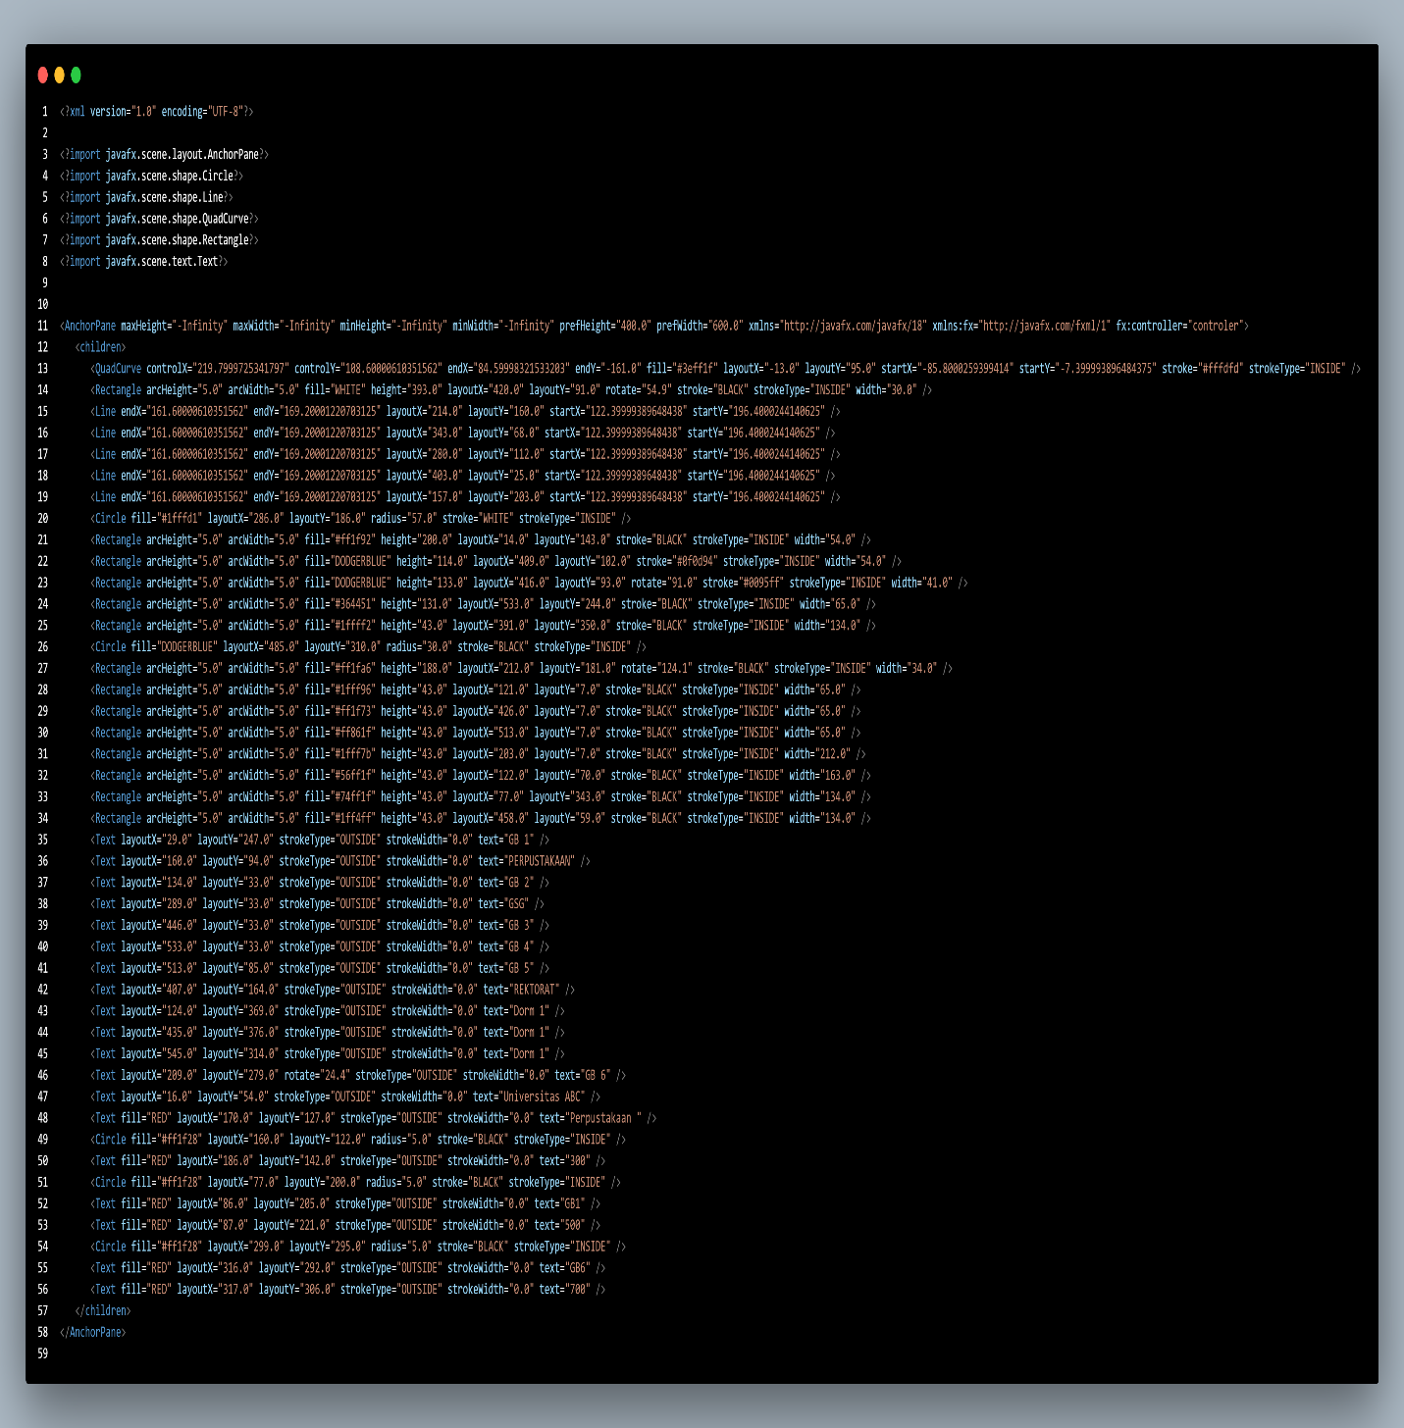

Execusi pogram:

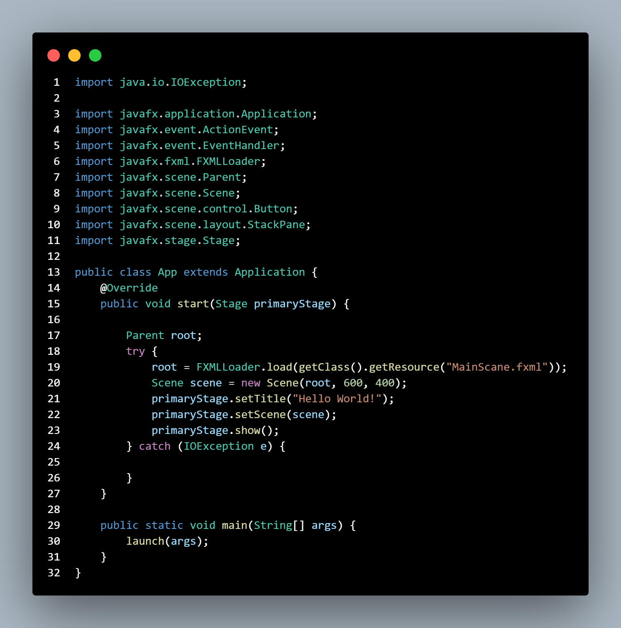

Outputnya :

